A.Ramesh Babu K.V.Acharya
Joint Convener Joint Convener,
Flat No 1103, Block 3B, J-208 Vijay Rattan Vihar,
S.M.R. Vinay Fountainhead, Sector 15, Part II,
Culvary Temple Road, Gurgaon 122001
Hyderabad 500 049 Mobile: 09868220338
Mobile: 09849381995 E-mail: acharyavedavyasa46@gmail.com
E-mail: babu2609@gmail.com
____________________________________________________________________________________
Dated: 21.10.2016
To
Com. M.V.Murali,
Convener UFBU,
C/o State Bank of India Staff union,
SBI Buildings,
Bank Street,
Hyderabad 500095

Sub: Renewal of Medical Insurance Cover for Retirees.
Dear Comrade
We understand that the leaders of United Forum of Bank Unions are meeting IBA on 26th October, 2016 to discuss about the sharp increase in the Insurance Premium both for Serving Employees and Retirees. The outcome of the meeting is being very eagerly awaited specially by the Bank Retirees as the increase in the premium is more than double the amount originally charged when the scheme was introduced while implementing the Xth Bipartite Settlement.
The Scheme when introduced came in the form of good relief to the Bank Retirees though of course we were expecting at that time that the premium amount would be borne by the Banks on the same lines as extended to the serving Employees. Still the Retirees opted for the scheme hoping that the Banks would eventually reimburse the entire premium amount. Unfortunately neither the Banks reimbursed the premium amount nor the domiciliary treatment promise carried out.
In view of the above, we request you to take up the case of the Retirees as a very special case and give relief to the Retirees, who are deeply depressed with the exorbitant increase in the premium amount. We also mention here under the grounds for such a request which need to be highlighted:
- The Department of Financial services, Ministry of Finance, GOI vide their letter F.No. 14/7/92-IR (vol-II) dated 24th Feb., 2012 to IBA has advised that a Medical Insurance Scheme should be devised to both for Serving Employees and Retired Employees and no where they had conveyed to recover the Insurance Premium amount from the Retirees.
- The Retirees are drawing meagre Pension and in fact they should be shown extra consideration in Medical Relief both in respect of premium amount and the coverage.
- The Family Pensioners are drawing a very meagre amount as pension and the present Premium proposed is very harsh as far as they are concerned especially in view of the fact that the claimant is only one.
- The claimants in respect of Retirees mainly restricted to Two Persons only i.e. self and spouse and in quite a good number of cases one only as either the Retiree or the Spouse would have already expired.
- The claim ratio as indicated by the Insurance Company and IBA and the percentage of increase thrusted on the Retirees is also a matter of proper verification by all the concerned and in the absence of any transparent information it is difficult to accept the calculations given by the Insurance Companies.
- The increase is also in violation of the IRDA provisions as regards to the lock in period and notice period for any change in the insurance premium suggested. This is also in violation of the most lauded principle of taking due medical care of the Retirees by the employer as pronounced by various Courts including Hon’ble Supreme Court and also as practiced in respect of Govt. Employees, Public Sector undertakings and Autonomous Bodies.
- The Retirees are in an awkward situation as many had already surrendered their individual level Medical Insurance policies in view of the Industry level Group Medical Scheme introduced in the last Bipartite Settlement. Now they cannot go back to the earlier Medical Insurance policy as they have become more aged and also they would have been affected by new ailments during the period. This handicaps them from opting for a new policy at all or even if they get, the pre existing diseases do not get covered.
- Even the Bank specific schemes earlier in vogue in respect of Group Medical Insurance Scheme and Medical Benefit Scheme have been discontinued by the Bank in the light of the Industry wise Group Medical Insurance Scheme.
- Lot of clarity is required in respect of domiciliary treatment reimbursement. The Insurance Company should go by the comprehensive meaning of domiciliary treatment only.
- The EDs, MDs and CMDs are given full and comprehensive Medical Relief even after their retirement though their tenure as ED, MD or CMD were for a short period whereas the Bank Retirees are denied the same relief though they had put in full and long years of service

In the light of the above, we are confident and hopeful that you will succeed in getting a fair deal so far as Insurance Premium is concerned both for Serving and Retired Employees. We also earnestly request you to remove the discrimination shown against the Bank Retirees by making the Banks to absorb the Insurance Premium of the Retirees fully.
Yours Comradely,
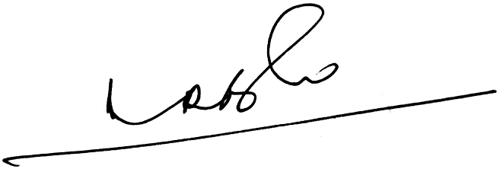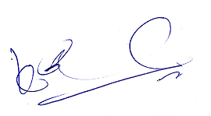
A.Ramesh Babu K.V.Acharya
Joint Conveners

