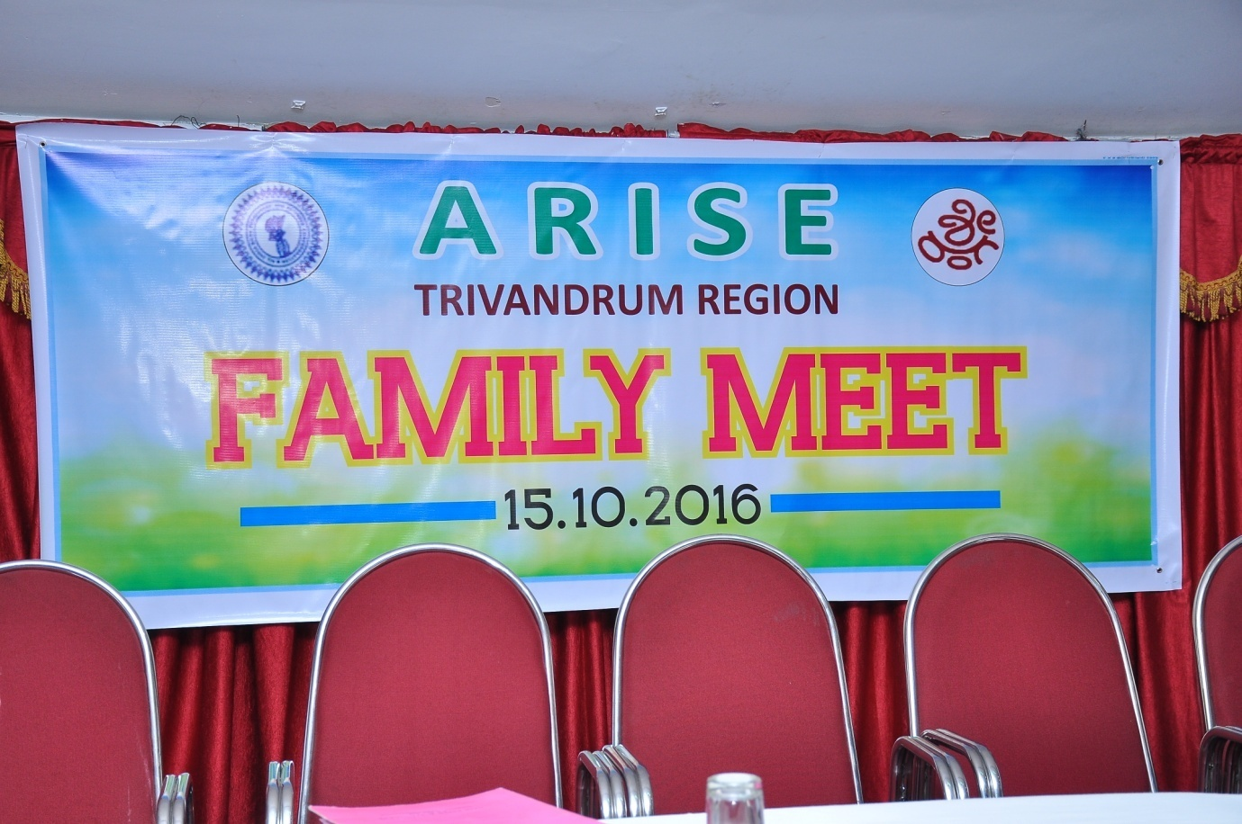

Banner on the dias Arise Family meet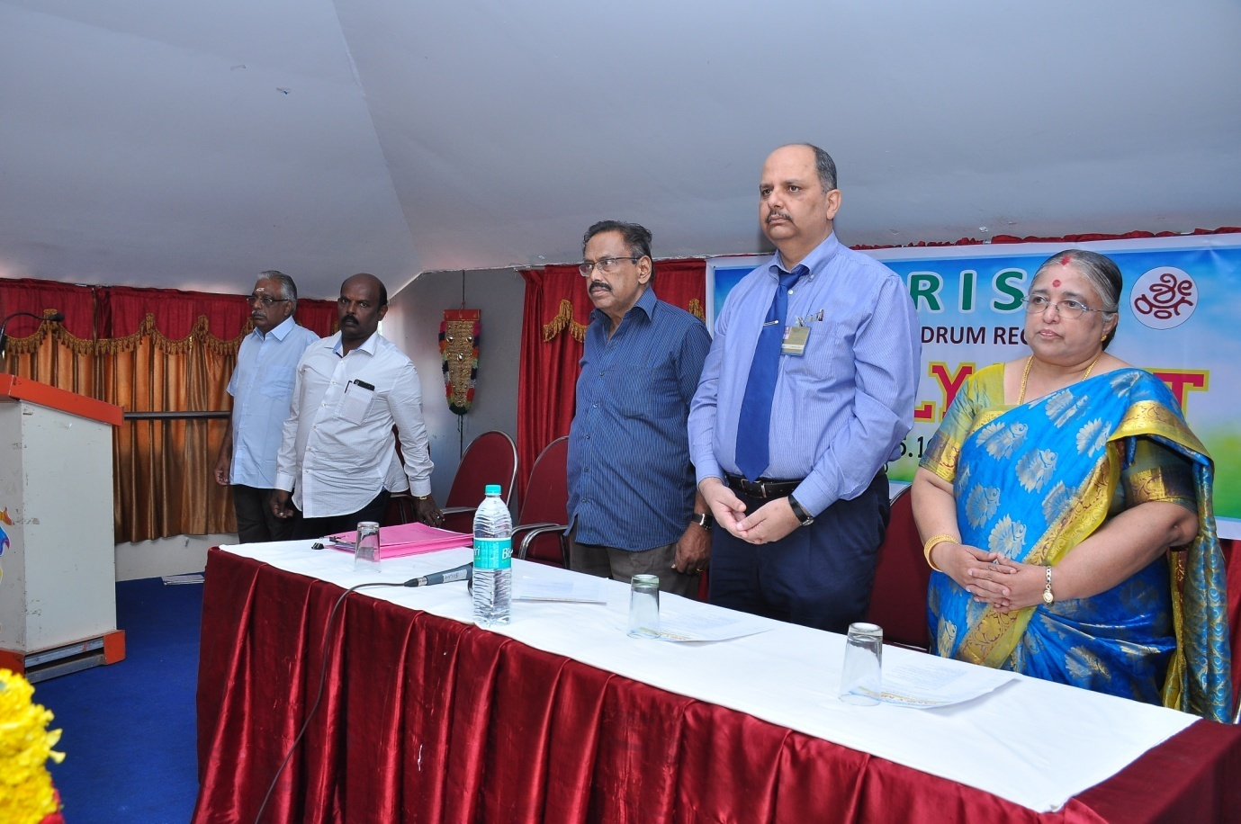

Prayer

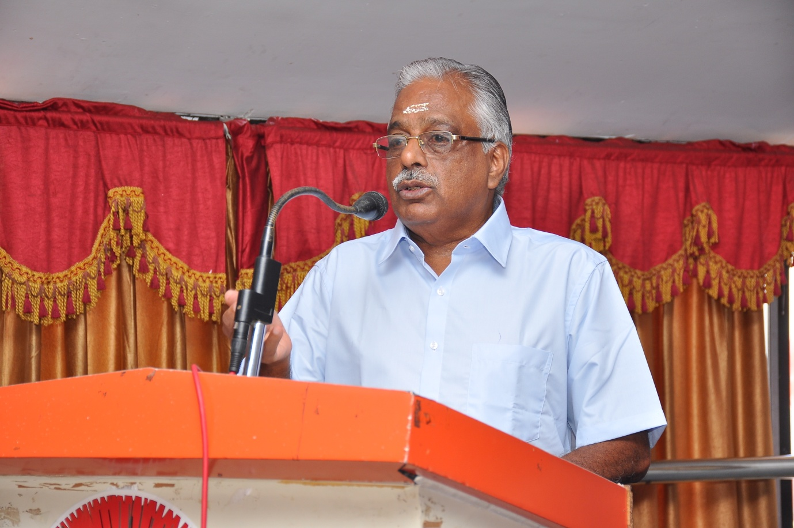

Welcome address by MR KR Ananthapadmanabhan AGS

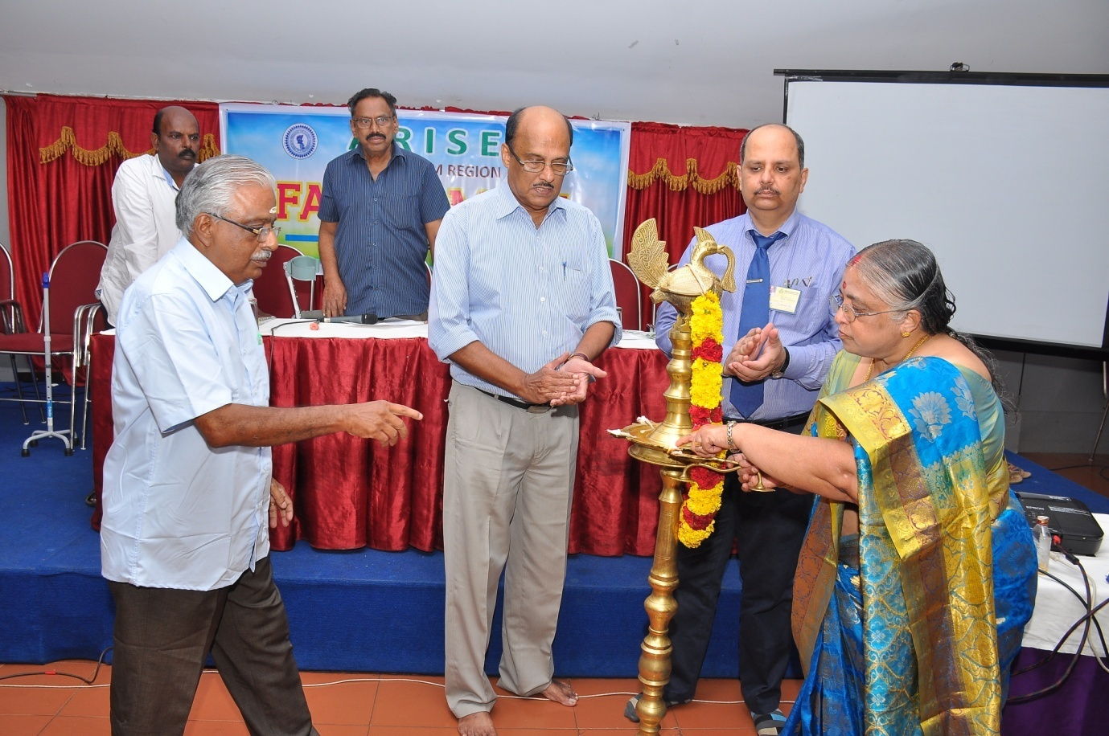Lighting the Lamp by Mrs Indira Padmini , Retired General Manager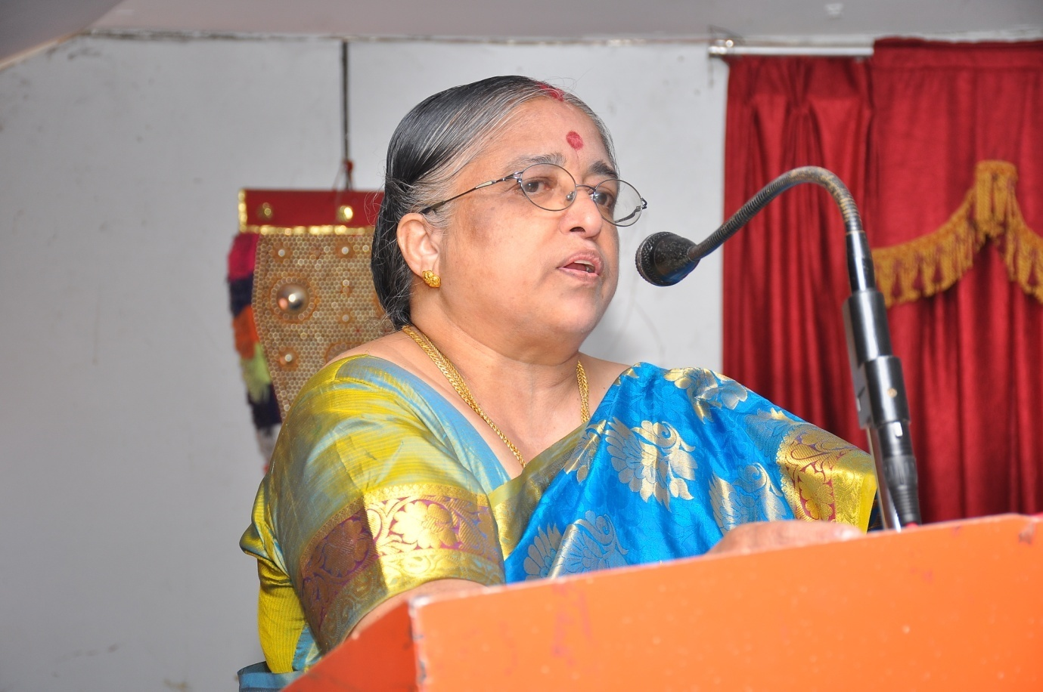

Inaugural Address by Mrs Indira Padmini

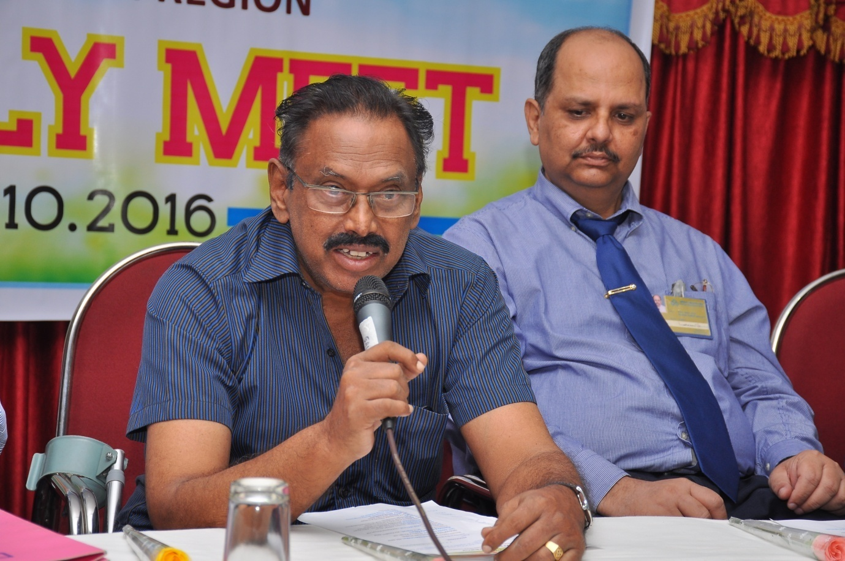Presidential Address by Mr V Gopinath (Vice President – Arise)

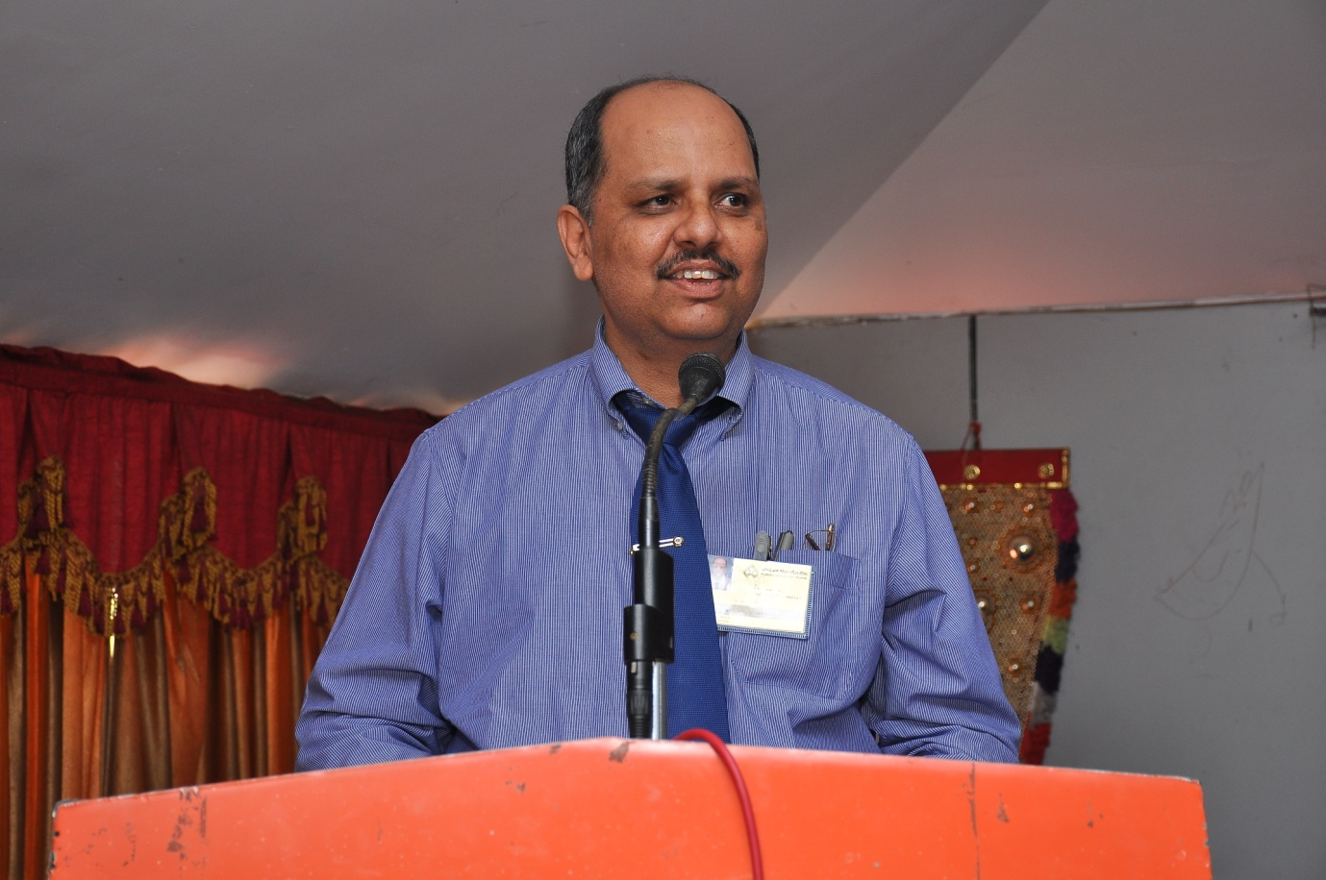

Key Note Address by Mr Rajesh Kumar Mathur (CRM Trivandrum)

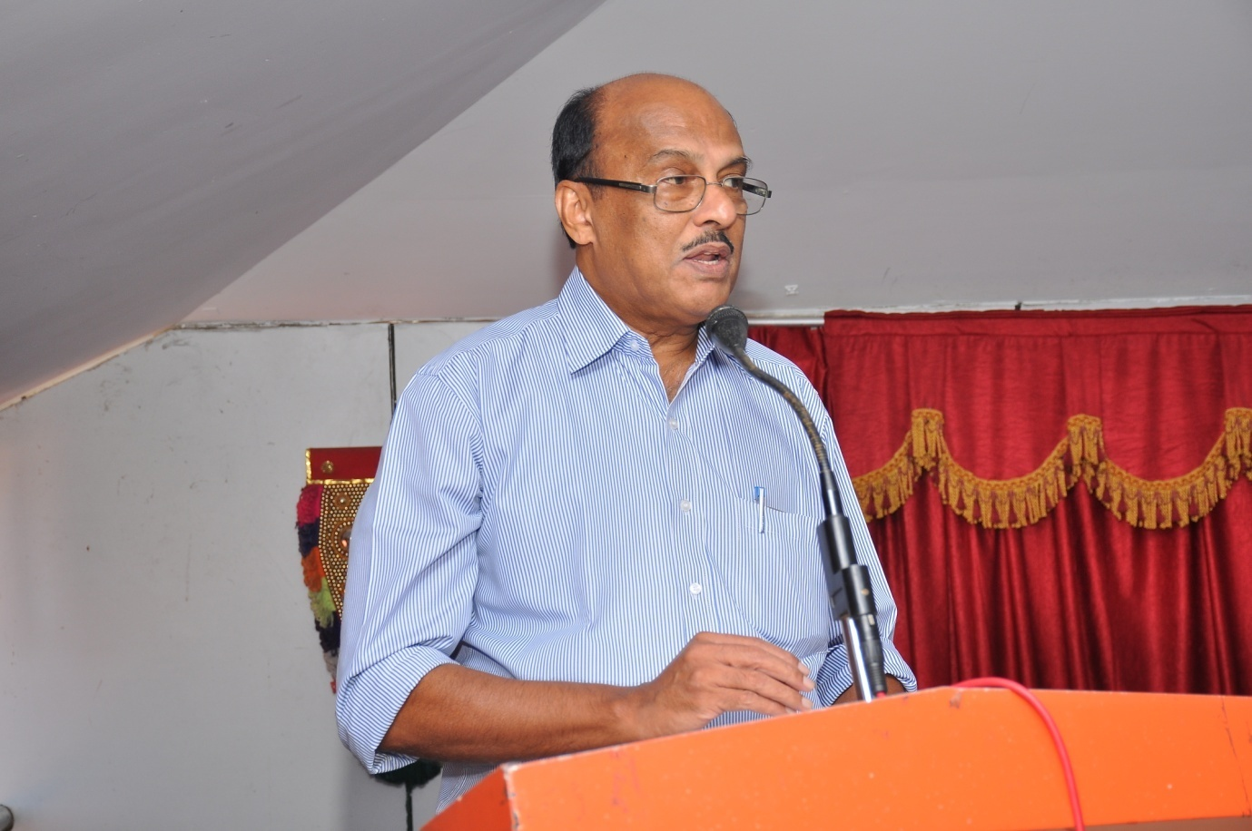

Felicitation address by R Chandrasenan (Secretary AIBPARC Kerala)

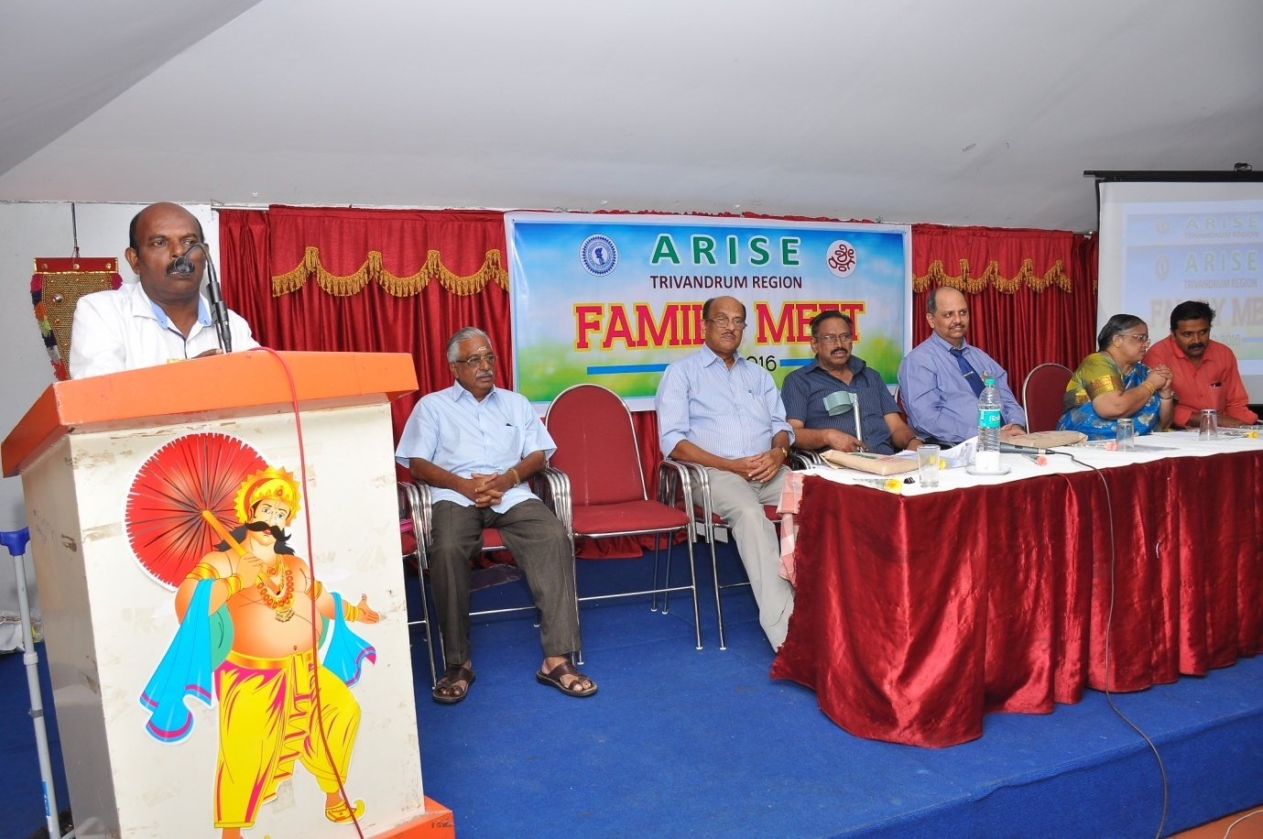

Felicitation by R Gireesh Kumar (Secretary AIBPARC Trivandrum)

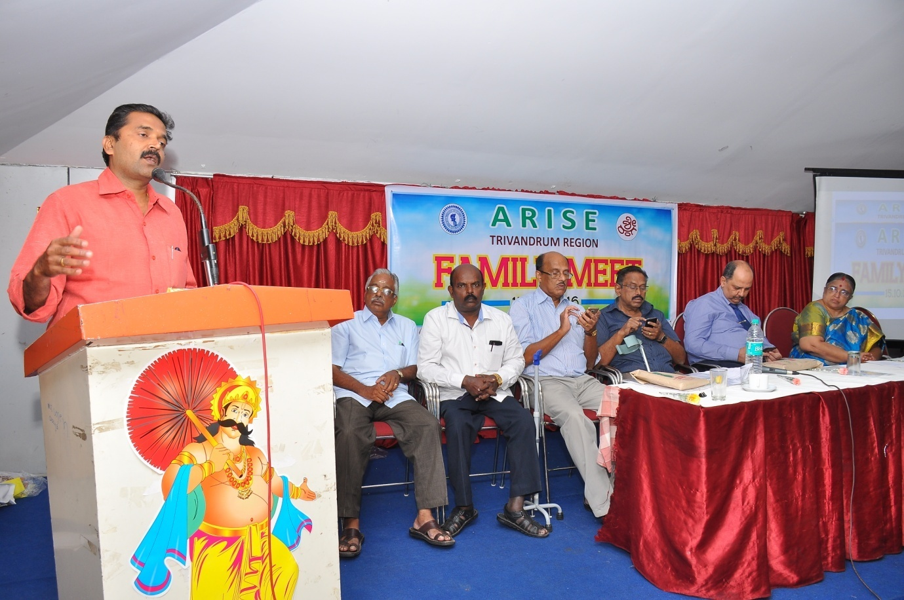

Felicitation by Mr Srinivasa Naick AGS IOBOA Trivandrum

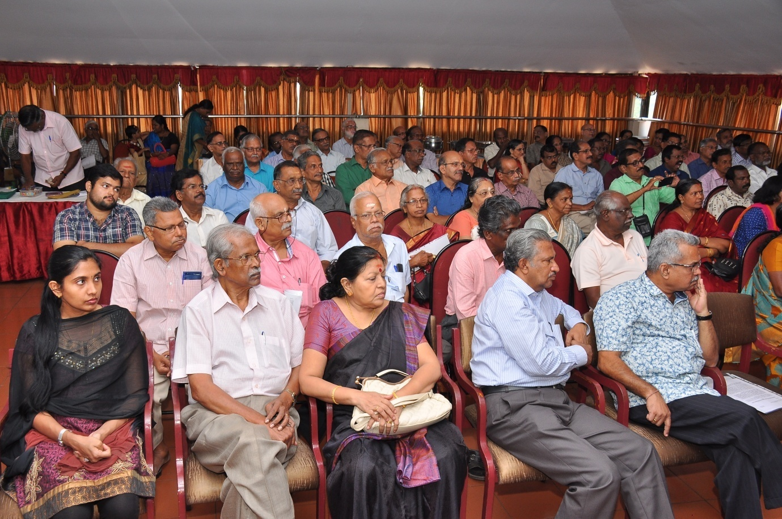

Attendees for the Arise Meet in Trivandrum

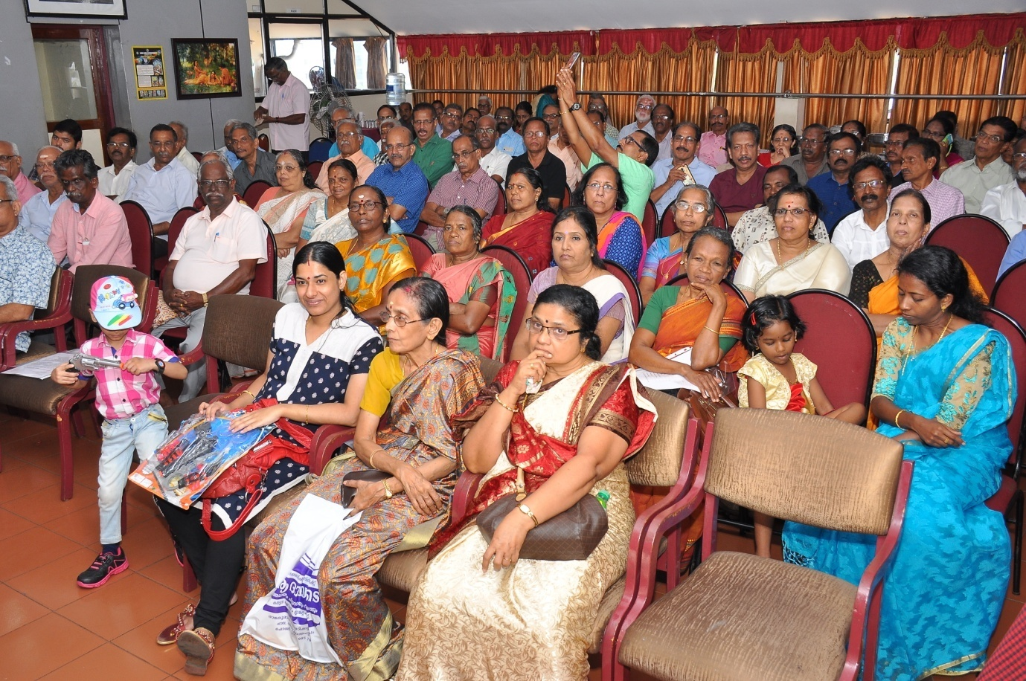

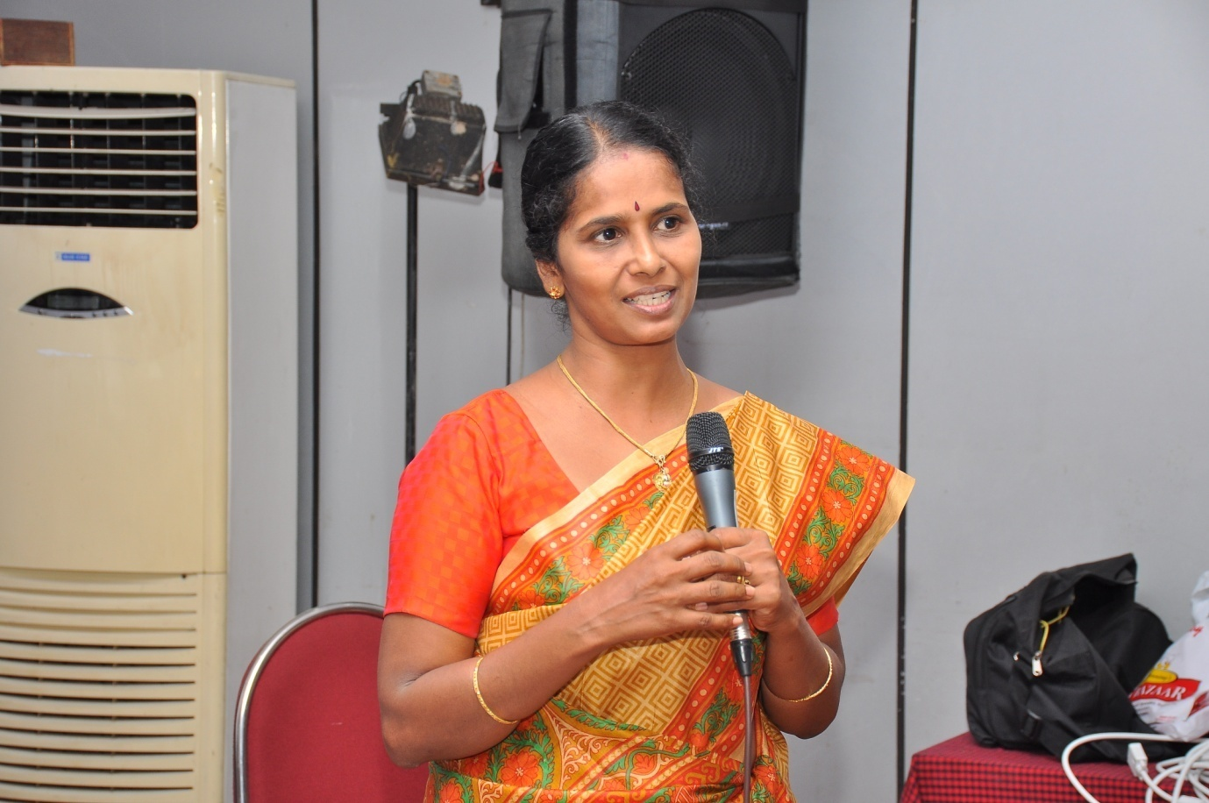

Address on Good Health Practices and Senior Citizens by Dr Anuja U