27th December, 2016

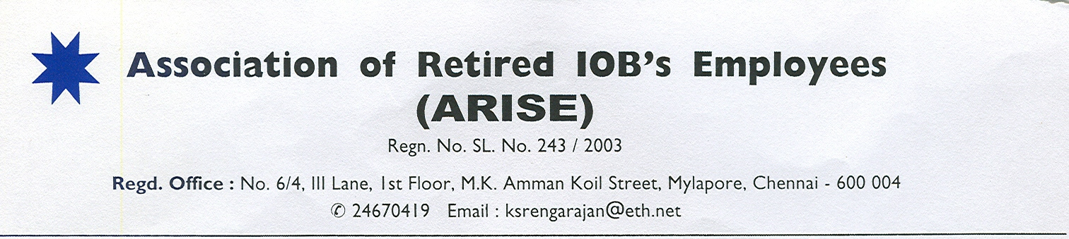

**The Executive Director**,

Indian Overseas Bank

Central Office,

763 Anna Salai,

Chennai 600002

**Dear Sir,**

**A Happy New Year & Best Wishes for the Turnaround**

We are pleased that you have put up to the Board your Turnaround plans for the bank. Though it should have been done more than a year ago it is better late than never. Though we are an organization of retirees we continue to evince interest in the business of the bank as habits die hard. We are reminded of the worst crisis the bank faced early 1990s when the bank posted the highest ever loss in the industry for two consecutive years and how the bank turned around with the active participation of every employee. The present crisis is equally bad if not worse. The situation is grimmer due to lack of awareness of the crisis itself or its extent among the employees unlike in 1990s.

We are fully conscious of the unenviable position you are in. Demonetization robbed the vital two months for every bank and the recovery plans for the bank have to be reworked. Added to this woe, is the impending retirement of 9 GMs in another 6 months creating a great stress on delegation of responsibilities. Surely, things are made difficult for one at the helm. Unlike the last crisis, you have the advantage of a large workforce of young age that has more advanced technological skills though of course, low on banking experience but eager to learn and share as I noticed from their large participation in social media to help each other during the implementation of Finacle. Then also, an Executive Director officiating as CMD (**Mr.Subramaniam K)** only led us out of the woods by inspiring all the employees through confidence building measures like making record number of promotions, enhancing entitlements of Staff and Retirees and taking into confidence the organizations of officers and employees. We trust and wish therefore that you **(Mr.Subramania K**umar**)** as Executive Director officiating as MD would repeat history or even better history.

True, we have strains with the HR department but not with the Bank. We would also discuss not all the time only about our strains as after all we are not cry-babies running to the Teacher every time. When Mr.K.V.Acharya and Mr.M.R.Gopinatha Rao visited Chennai in connection with our General Body Meeting we wanted to call on you mainly to extend our cooperation and wish you success on your Turnaround plans, and to share their thoughts for whatever they are worth. We took the decision not to pursue the matter of HR department for the present with you in view of the more urgent things you have on hand. However we request you to redress our grievances which we have already listed in our earlier letter viz. *i) Bank’s contribution to NMIS premium for Remas members* ( A detailed letter has also been sent by Mr.K.V.Acharya and hence not repeated except reiterating that *it is a question of fair play and good conscience* inasmuch as the REMAS corpus was built by part contribution from retirees which still continues on bank’s commitment to bear a good portion of insurance commitment ) *ii) Removing the cap on extra interest payable on deposits of Senior citizen IOB ex-employees, iii) At-par with staff in the matter of charges for remittances, internet/mobile banking, SMS alerts and other banking services iv) Terminal benefits to retirees where proceedings by external agencies are anticipated or under way and v) Leave encashment to all compulsorily retired officers irrespective of the date of compulsory retirement.*

Coming back to the larger issue of Turnaround, you must have also gone through the turnaround strategies of every corporate and might have even carried out revival of sick corporate in your long innings. A few things that used to stand out in all those strategies are – i) Focus on **core competencies** ii) Strengthen the defences i.e. play conservative which in the context of our bank’s crisis can mean **low-risk appetite** iii) Inspire and involve employees across cadre iv) Update and upgrade the skills of employees v) Know your market and go & get them.

We are reminded of the post-2008 turnaround of Abu Dhabi Commercial Bank (ADCB) whose new CEO Ala’aEraiqat led by example and ***refused to cut corners****( i.e He never cut any service that is already available to the customers but cut only all avoidable/wasteful expenditure with the involvement of all staff ).* By *focusing on core competencies and a level of transparency previously unheard of in the region, he steered the bank through this most turbulent period.*Heensured that every employee was **aware of the crisisand** of each **hard-won success** that came from the turnaround effort. To demonstrate his conviction that results come from people, the new CEU made a commitment to every staff member that **no-one would be fired on account of the crisis.***(In our context, this assurance can be modified as no transfer without consent to distant places/outside State/Zone upto certain scale/grade).* Competitors such as Citibank or HSBC were able to come in with their private banking divisions and syphon off some of the wealthiest Emiratis ― So ADCB didn’t go after that segment, but they certainly went after credit cards and the micro businesses. The small and medium support firms for the petroleum sector were all targeted as ADCB customers.

You might have also fashioned a Turnaround strategy of such sort and we are confident that you have in you to lead from the front. More visibility to the workforce and easy accessibility to them would go a long way.

Well, We are all with you. Best wishes to all yourendeavour to take the bank to its past glory.

A very happy New Year to you and your family.

**(S.B.C.Karunakaran) (K.S.Rengarajan)**  General Secretary President