A.Ramesh Babu K.V.Acharya
Joint Convener Joint Convener,
Flat No 1103, Block 3B, J-208 Vijay Rattan Vihar,
S.M.R. Vinay Fountainhead, Sector 15, Part II,
Culvary Temple Road, Gurgaon 122001
Hyderabad 500 049 Mobile: 09868220338
Mobile: 09849381995 E-mail: acharyavedavyasa46@gmail.com
E-mail: babu2609@gmail.com
____________________________________________________________________________________
Dated: 27.12.2016
The Chairman,
Indian Banks’ Association
Mumbai.

Dear Sir,

Sub: 100 % DA Neutralization to pre 2002 Retirees
Judgment of the Division Bench of Hon’ble High Court of Kolkata.

Though Bank Trade Unions were fighting for pension as a third benefit in addition to PF, they had to settle at the insistence of the Government for Pension only as a second benefit in lieu of Provident Fund as obtaining under Central Government Employees’ Pension Rules on which RBI Employees’ Pension Scheme is modeled. In fact, the DA though payable at quarterly average for Serving Employees in Banks it is payable at half yearly average to Bank Pensioners merely because it is so payable to Central Government and RBI Pensioners. It is therefore evident that RBI is following Central Government Pension and Banks are following RBI Pension scheme modeled on Central Government Pension Scheme.

Banks’ 6th Bipartite Settlement dated 29th October, 1993 specifically provided for payment of DA to Pensioners as applicable to RBI Pensioners from time to time. It was so paid till and including the 8th Bipartite when RBI switched from tapering DA to 100% DA neutralization to all those who retired on or after 1/11/2002. In view of the above settlement, Banks also extended 100% DA neutralization like RBI to all those Pensioners who retired on or after 1/11/2002. However accepting this distinction of Pensioners on the basis of retirement date as unreasonable, inequitable and not in accordance with the Central Government Pension Rules, RBI extended 100% DA neutralization to all those who retired before 1/11/2002. Having thus far implemented the 6th Bipartite Settlement dated 29th October, 1993, Banks discontinued implementation of the settlement all of a sudden. The matter was agitated in various Courts by Various fora of Pensioners. United Bank of India Retirees’ Welfare Association litigated before the Hon’ble High Court of Kolkata where they won the writ and writ appeal. Their review petition to modify the clerical/typographical errors were also allowed and consequently United Bank of India has been directed to pay 100% DA neutralization to the Pensioners who retired before 1/11/2002 in terms of the above Bipartite Settlement. We only wish and hope the Poor Retirees in their ripe age cannot be and should not be asked to wait endlessly every time till an issue is settled by the Hon’ble Supreme Court in spite of their winning the cases at the High Court.

As this government is known for its care for the weak and powerless, the Bank Retirees only have expectations and have been hoping for an end to endless litigations in service matters and the Government will be more inclined to be employee-friendly. Moreover the Hon’ble Prime Minister is also highly appreciative of the contributions made by the Retirees during the demonetization exercise in reducing the work pressure of the Banks’ workforce. He has also exhorted Senior Citizens should not be put to hardships by the Government and their Agencies by indulging in unnecessary litigations.

Your good-self may appreciate that DA is only a protection against inflation and it does not give any additional real wages to the Pensioners. The delaying approach has caused many Pensioners leave this world without ever having this full protection against inflation by 100% DA neutralization. Pre Nov, 2002 Pensioners are a dwindling lot who are going to fade away completely in a few years from now. With the fast disappearance of this group, the Pension expenditure will only come down on account of these pensioners. In other words, the additional outlay on account of those who retired before November 2002will decline year after year soon reaching NIL in a few years.

Though the Retirees are more likely to win the litigation in the Hon’ble Supreme Court, the IBA would do well to bestow the benefit of 100% DA neutralization on its own and this gesture will not go unnoticed and will not go unreciprocated by the Retirees.

As Joint Conveners of CBPRO, an umbrella organisation comprising almost all the organisations of retirees in the Banking industry we once again appeal to you to honour the judgment of the Division Bench of the Hon’ble High Court of Kolkata in respect of DA petition filed by United Bank of India Retirees’ Welfare Association and put an end to the sufferings of the very very aged Retirees who are virtually counting their days. Your most urgent action in this regard will be highly appreciated and justice delivered to them even at this advanced age.

Thanking you,

Yours sincerely,
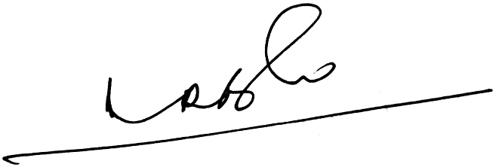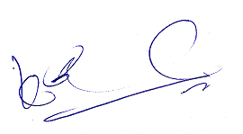
A.Ramesh Babu K.V.Acharya
Joint Conveners CBPRO

