A.Ramesh Babu K.V.Acharya
Joint Convener Joint Convener,
Flat No 1103, Block 3B, J-208 Vijay Rattan Vihar,
S.M.R. Vinay Fountainhead, Sector 15, Part II,
Culvary Temple Road, Gurgaon 122001
Hyderabad 500 049 Mobile: 09868220338
Mobile: 09849381995 E-mail: acharyavedavyasa46@gmail.com
E-mail: babu2609@gmail.com
____________________________________________________________________________________
Circular No. 01/2017 Dated: 21.01.2017
TO ALL THE CONSTITUENTS OF CBPRO

DEAR COMRADES,

DEMONSTRATIVE ACTION BY CBPRO ON THE ISSUES OF THE BANKS’ PENSIONERS AND RETIREES.

WE WISH YOU ALL A VERY HAPPY NEW YEAR

You are well aware that the issues of the Banks’ Pensioners and Retirees are being ceaselessly and sincerely followed up at all possible levels by CBPRO; be it with IBA, Government, Administrative forums or even through the repeated personal visits to different Hon’ble Ministers and Ministry Officials. However, in view of the one reason or the other, including the latest demonetization exercise our issues have failed to elicit any attention despite the best efforts put in by CBPRO. Therefore, in consultation with all the Constituents of the CBPRO, it is decided to finalize the following Demonstrative action Programme:

- 15.02.2017 (Wednesday) — Deputation by Representatives of all the CBPRO Constituents to the Indian Banks’ Association, Mumbai.

- 15.03.2017(Wednesday)—Massive Demonstration, Dharna and Hunger Strike at Jantar Mantar, New Delhi by all the Constituents of CBPRO from 10.00 AM onwards.

FROM 15.02.2017 TO 15.03.2017, THERE WILL BE MASSIVE DEMOSTRATIONS AND DHARNAS IN STATE CAPITALS AND IN IMPORTANT CENTRES BY STATE UNITS OF CBPRO ALL OVER THE COUNTRY.

Comrades, this decision to go for the aforesaid Demonstrative Action had to be taken, as all the following issues of the Pensioners and Retirees have gone unheeded and have fallen prey to the so common policy of procrastination or the lip sympathy, at all levels despite repeated knocks at every possible door by CBPRO.

*UP DATION OF PENSION
*100% DA NEUTRALISATION TO PRE 2002 RETIREES.
*REVISION IN FAMILY PENSION IN LINE WITH GOVERNMENT AND RBI PENSIONERS.
*MEDICAL INSURANCE PREMIUM SHOULD BE FULLY BORNE BY THE BANKS AS IS DONE IN THE CASE OF SERVING EMPLOYEES.

We request the outstation comrades to make their travel arrangements immediately to participate in the Dharna on 15.03.2017 at Jantar Mantar, New Delhi in large numbers and to ensure that all the action programmes become an unprecedented and stupendous success.

WE REQUEST OUR COMRADES TO COME ONE AND COME ALL, BUT COME THEY MUST.

Thanking you,

Yours comradely,
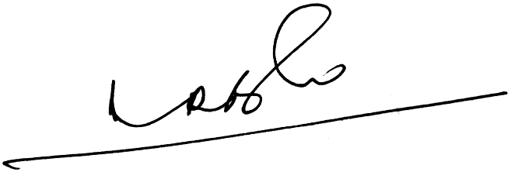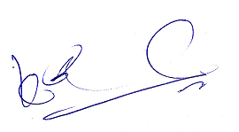
A.Ramesh Babu K.V.Acharya
Joint Conveners

