A.Ramesh Babu K.V.Acharya
Joint Convener Joint Convener,
Flat No 1103, Block 3B, J-208 Vijay Rattan Vihar,
S.M.R. Vinay Fountainhead, Sector 15, Part II,
Culvary Temple Road, Gurgaon 122001
Hyderabad 500 049 Mobile: 09868220338
Mobile: 09849381995 E-mail: acharyavedavyasa46@gmail.com
E-mail: babu2609@gmail.com
____________________________________________________________________________________
Dated: 27.01.2017
The Chairman,
Indian Banks’ Association
Mumbai.

Dear Sir,

Sub: Delegation of CBPRO to submit Memorandum regarding Bank Pensioners’ Issues.

We have been representing to IBA on several occasions in the past to resolve the long pending issues of Bank Pensioners and Retirees. However no forward movement has taken place in respect of any of the issues that we have raised so far. The Bank Retirees are an ageing population with lot many physical ailments and suffering from deprivations due to non consideration of their following issues:

- PENSION UPDATION.
- 100% DA NEUTRALISATION TO PRE-2002 RETIREES.
- IMPROVEMENT IN FAMILY PENSION
- COMPREHENSIVE MEDICAL RELIEF

As the above issues are not redressed so far the CBPRO has decided to come and meet your Good-self personally and submit a Memorandum to you to impress upon the IBA the necessity to consider the above issues on an emergency basis immediately. Hence a delegation of CBPRO consisting of about Fifteen(15) representatives of the Constituents of CBPRO namely Federation of SBI Pensioners’ Associations, AIBPARC, RNBOC, AIRBEA and FORBE commanding more than Three(3) lakhs Retirees of SBI, Public Sector and Private Banks Retirees will be meting your Good-self on 15th February, 2017 at 12.00 noon.

We are hopeful of a fruitful meeting with your Good-self which will pave the way for resolution of our pending issues at the earliest.

Thanking you,

Yours sincerely,
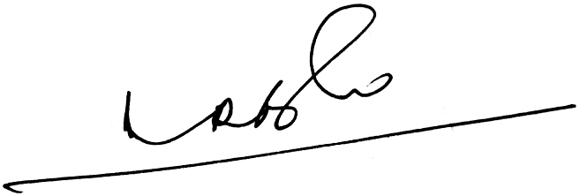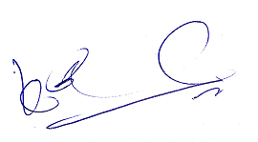
A.Ramesh Babu K.V.Acharya
Joint Conveners CBPRO

