A.Ramesh Babu K.V.Acharya
Joint Convener Joint Convener,
Flat No 1103, Block 3B, J-208 Vijay Rattan Vihar,
S.M.R. Vinay Fountainhead, Sector 15, Part II,
Culvary Temple Road, Gurgaon 122001
Hyderabad 500 049 Mobile: 09868220338
Mobile: 09849381995 E-mail: acharyavedavyasa46@gmail.com
E-mail: babu2609@gmail.com
____________________________________________________________________________________
Circular No.008/2017 Dated: 05.06.2017
To All Constituents of CBPRO

Dear Comrades

CBPRO Meeting on 23rd May, 2017 at Kolkata

We are happy to report about the proceedings of the CBPRO meeting presided over by Shri R .N. Banerjee, Chairman CBPRO.

The meeting was attended by the Joint Conveners and Shri Deepa kumar Basu, Secretary, Federation of SBI Pensioners’ Associations, Shri S.Sarkar, General Secretary AIBPARC, Shri H.S. Banerjee, Shri S. Saha, Shri S. Roy Biswas of RBONC and Shri S.V. Chaudhury, Shri A.N.Madhusudan and Shri A.G. Ghatte of FORBE. Shri R.K. Acharya of AIRBEA could not attend the meeting as his father was hospitalized. However, he sent a message by mail reassuring and endorsing the decisions that would be taken in the meeting.

The Chairman Shri R.N. Banerjee in his introductory remarks observed that the time is difficult for the Retirees. All out efforts have been employed in all fronts but results are not forthcoming. He praised the functioning of CBPRO and asked to carry on organizational activities with more zeal.

Shri K.V. Acharya stated about the possibility of an audience with Hon’ble Finance Minister Shri Arun jaitleyji on 2nd June, 2017. Within a very few days, leaders of AIBPARC will have separate sittings with Shri D.T. Franco, General Secretary AIBOC and Shri C H Venkatachalam, General Secretary AIBEA. He also informed that he had dialogue with Shri Y. Sudarshan, Chairman AIBOC on the issue of Retirees.

Shri A. Ramesh Babu, Joint Convener, CBPRO placed a written report on the functioning of CBPRO in between the last meeting and the present one. He explained in brief the efforts made by Sri K.V.Acharya one of the Joint Conveners stationed in Delhi, for taking initiative to meet many functionaries at the Banking Department & Ministry of Finance.

The agenda for discussion was placed before the members. All the constituents of CBPRO participated in the deliberations.

- The 1st item of discussion was Charter of Demands.

AIBPARC handed over the draft copy of its Charter of Demands to all the Constituents. After discussion, it was agreed that all the Constituents of CBPRO would go through it and make their suggestions on inclusion/ amendment/ deletion and forward the same to the conveners of CBPRO before 15th of June 2017 positively.

- Activities of CBPRO and strategy to be taken in future

After hearing the representatives of all the Constituents, it was decided that CBPRO would meet formally with UFBU and request them to give top priority to our issues. At the same time, we shall carry on our efforts to maintained liaison with IBA, bureaucracy and political leadership to see that our issues are looked into.

- Mail dated 02.04.2017 sent by Shri S.C. Jain, General Secretary AIBRF to the Joint Conveners placed for discussion before the CBPRO Constituents.

There was an in depth discussion on the subject. It was unanimously agreed as under:

“All of us have assembled here with the sole purpose of doing something good for the Retirees. We discuss our problems across the table and come to unanimous conclusions and decisions. None of us joined CBPRO with any prior conditions. As such the suggestions of AIBRF to change the name of CBPRO to UFBRO and also change the setup and structure of CBPRO are not in line with the spirit of the coordination. However, the constituents would be happy to welcome AIBRF to CBPRO without any condition”.

The CBPRO also would be happy to have coordinated action program with AIBRF mutually. The Joint Conveners were directed to send the CBPRO response to AIBRF’s letter assuring them of our willingness to have coordinated and consulted actions and efforts to achieve and meet the expectations and aspirations of Bank Pensioners and Retiree.

The meeting ended with vote of thanks by Shri S.Sarkar, who expressed confidence of CBPRO achieving success by finding out proper resolutions to the long pending issues of Bank Pensioners and Retirees.

After the meeting of CBPRO the Joint conveners sent a response to Shri S.C. Jain, General Secretary AIBRF on 30.05.2017 as per the directions of the Constituents of the CBPRO.
After the CBPRO meeting at Kolkata the delegation of CBPRO met the Hon’ble Finance Shri Arun Jaitleyji on 2nd June, 2017 and submitted a memorandum and explained him about the long pending issues of Bank Retirees. The copy of memorandum is already circulated to the constituents.
Shri K.V. Acharya, Joint Convener also met Shri D.T. Franco, General Secretary AIBOC and Shri C H Venkatachalam, General Secretary AIBEA with the other leaders from Chennai on 26th May, 2017 requesting them to take up the issues of Bank Pensioners and Retirees with IBA and other concerned Authorities. We have also taken up the matter with Shri Sanjeev Kumar Bandlish, Convener of UFBU. We are happy for their assurances and positive responses to our request.
The Joint Conveners report is enclosed herewith for reference.
Thanking you,
Yours Comradely,

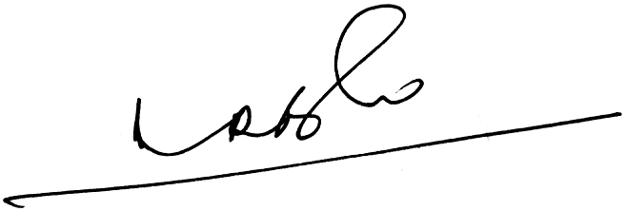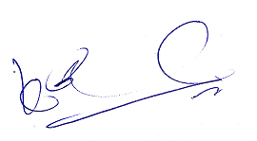
A.Ramesh Babu K.V.Acharya
Joint Conveners CBPRO

