A.Ramesh Babu K.V.Acharya
Joint Convener Joint Convener,
Flat No 1103, Block 3B, J-208 Vijay Rattan Vihar,
S.M.R. Vinay Fountainhead, Sector 15, Part II,
Culvary Temple Road, Gurugram -122001
Hyderabad 500 049 Mobile: 09868220338
Mobile: 09849381995 E-mail: acharyavedavyasa46@gmail.com
E-mail: babu2609@gmail.com
------------------------------------------------------------------------------------------------------------------------
Dated: 26.07.2017
Shri V G Kannan,
Chief Executive,
Indian Banks’ Association
Mumbai.

Dear Sir,
Super Top-UP Medical Insurance Policy for Bank Retirees.
We are a Confederation of five major organisations namely Federation of SBI Pensioners Associations, AIBPARC, RBONC, AIRBEA and FORBE representing more than four lakhs Retirees in the Banking Industry. The Retirees are presently covered under Medical Insurance policy of United Insurance Company to the extent of Rs 4.00 lakhs in case of Officers and Rs 3.00 lakhs in case of award staff. This policy was introduced at the behest of Indian Banks’ Association in the year 2015 as a sequel to industry level settlement. It has been the experience of the members covered under the medical insurance scheme for Retirees that the amount of medical insurance provided under the scheme is inadequate. Accordingly our affiliate organisations have been taking up with United India Insurance Company for additional medical insurance cover under Super Top Policy. After consistent follow-up, United India Insurance Co has agreed for the following additional coverage to the existing policy under Super Top Up Policy.
- For Award Staff
- Original sum insured Rs 3.00 lakhs.
- Additional coverage under proposed Super Top-Up Policy Rs.4.00 lakhs at a premium of
Rs. 2975/- plus GST as applicable.
- Total coverage Rs 7.00 lakhs.

2. for Officers:
(a) Original sum insured Rs 4.00 lakhs.
- (b) Additional coverage under proposed Super Top-Up Policy Rs 5.00 lakhs at a premium of
Rs. 3225/- plus GST as applicable.
- Total coverage Rs 9.00 lakhs.
The claims under the Super Top Up Policy shall be entertained only after exhausting the entire sum insured in the main policy of United India Insurance Co. It is also proposed that the claim towards domiciliary treatment shall be restricted only in the main policy under the existing terms without providing the facility of domiciliary claim under the enhanced amount on account of Super Top-Up Policy.
K M Dastur & Co has already advised the details of the proposed Super Top-Up Policy to different organisations of employees & officers and also to IBA and to all the member Banks.
In as much as the original scheme was introduced during the Industry level settlement, it would be appropriate if the Super Top-Up Policy is formally advised by IBA to the member Banks so as to ensure uniformity of the coverage and its smooth implementation at the industry level. We therefore request you to initiate suitable steps to formalise the proposed arrangement to implement Super Top-Up Policy of United India Insurance Company.
Notwithstanding the above arrangement, we reiterate our demands for the medical cost in case of Retirees to be borne by the Banks as is done for the serving employees. We also request you to formulate a comprehensive medical benefit scheme as also demanded by UFBU to cover the Retired Bank Employees and also as requested by us in the past as well as mentioned in our Charter of Demands. Since the main medical insurance policy is due for renewal in a couple of months’ time, we request you to undertake a comprehensive review of the scheme as per our earlier request.
Thanking you,
Yours faithfully,
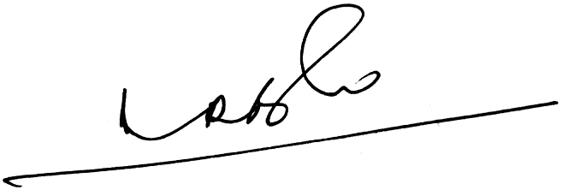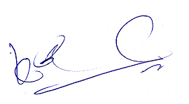
A.Ramesh Babu K.V.Acharya
Joint Conveners

