**A.Ramesh Babu K.V.Acharya**

**Joint Convener Joint Convener,**

**Flat No 1103, Block 3B, J-208 Vijay Rattan Vihar,**

**S.M.R. Vinay Fountainhead, Sector 15, Part II,**

**Culvary Temple Road, Gurugram -122001**

**Hyderabad 500 049 Mobile: 09868220338**

**Mobile: 09849381995 E-mail: acharyavedavyasa46@gmail.com**

**E-mail:** [**babu2609@gmail.com**](mailto:babu2609@gmail.com)

**__________________________________________________________________________________**

**Dated: 26.07.2017**

Shri Sanjeev K Bandlish

Convenor,

United Forum of Bank Unions,

Chandigarh

Dear Com. Bandlish

Sub: **Super Top-UP Medical Insurance Policy for Bank Retirees.**

We are the largest confederation of major organisations of Retirees namely Federation of SBI Pensioners’ Associations, AIBPARC, RBONC, AIRBEA AND FORBE representing more than four lakh retirees in the Banking Industry. The medical Insurance Scheme for Retirees was introduced in terms of industry level settlement between UFBU and IBA. The scheme provided for coverage of Rs. 4.00 lakhs in case of officers and Rs. 3.00 lakhs in case of award staff retirees. We are happy that introduction of the Medical Insurance Policy provided a great relief to the Retirees who did not have any medical facility. It is praiseworthy that UFBU played a vital role in getting the facility of Medical insurance to the Retirees.

Some of the affiliates of CBPRO constituents had taken up the matter with the United India Insurance Co. for enhancing the Medical insurance cover by providing super top-up Medical Insurance Policy over and above the main policy. Accordingly United India Insurance Company has agreed for Super Top-up Policy in addition to the main policy whereby providing a coverage of Rs. 5.00 lakhs for officers and Rs. 4.00 lakhs for award staff at an additional premium of Rs. 3225/- and Rs. 2975/- respectively plus GST as applicable.

In this connection we have written a letter to IBA (copy of letter enclosed) requesting them to take suitable steps to advise all the Member banks about the Scheme and formalise its implementation and maintain uniformity of the coverage and cost. Since the original scheme is covered under the policy of United India Insurance Company, it would be appropriate to implement the Super Top-up Scheme through the same company for better and smooth administration. We therefore request the leaders of UFBU to use their Good-offices to impress upon IBA to arrange for the implementation of Super Top-up Policy.

We also request you to reiterate our demand for absorption of the cost of Insurance premium by the Banks as in the case of serving employees. It would also be desirable to have a comprehensive review of the Medical Benefit Scheme for Retirees as incorporated in the Charter of Demands submitted to IBA. We are confident that initiative on your part shall bear fruits and provide much desired relief to the Bank Retires.

Yours Comradely,

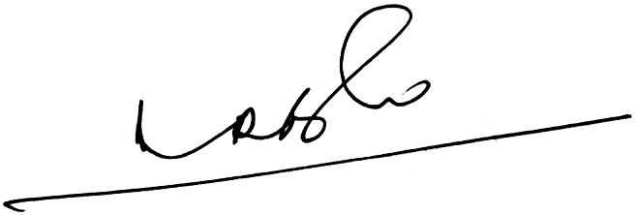 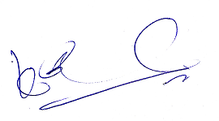

**A.Ramesh Babu K.V.Acharya**

**Joint Conveners**