**A.Ramesh Babu K.V.Acharya**

**Joint Convener Joint Convener,**

**Flat No 1103, Block 3B, J-208 Vijay Rattan Vihar,**

**S.M.R. Vinay Fountainhead, Sector 15, Part II,**

**Culvary Temple Road, Gurugram -122001**

**Hyderabad 500 049 Mobile: 09868220338**

**Mobile: 09849381995 E-mail: acharyavedavyasa46@gmail.com**

**E-mail:** [**babu2609@gmail.com**](mailto:babu2609@gmail.com)

**__________________________________________________________________________________**

**Circular No. 012/2017 Dated: 12.08.2017**

**To**

**The General Secretaries, Constituents of CBPRO.**

**Dear Comrades,**

**Sub: CBPRO SUBMITS CHARTER OF DEMANDS TO IBA ON 9TH AUGUST 2017.**

As per the decision taken in our Kolkatta meeting held on 23rd May, 2017, the Charter of Demands raising the issues of Bank Pensioners and Retirees prepared by us was formally submitted to Indian Banks' Association at their office in Mumbai. The team of CBPRO Consisted of representatives of all the five Constituents, Comrades Shri S B Gokhale and Shri Rajwadeker of Federation of SBI Pensioners’ Associations, Shri Supritho Sarkar, Shri K .V. Acharya and Shri Shekhar Kadam of AIBPARC, Shri Vasanth Upadhyaya of RBONC, Shri R.K. Acharya and Shri N K Joshi of AIRBEA and Shri S V Chaudhry and Shri Bhaskar Manakeshwar of FORBE.

The Charter of Demands was presented to Shri V.G. Kannan, Chief Executive,IBA. We also discussed the various issues contained in the Charter of Demands with Shri V.G.Kannan, Chief Executive, Shri Rajkumar, Deputy Chief Executive, and Shri S K Kakkar, Senior Advisor (HR & IR). We also talked to Shri K.S. Chauhan, Senior Vice- President, IBA. We urged upon IBA that the items mentioned in the Record Note of last settlement should get priority and resolved before the conclusion of the ongoing Wage negotiations. We also pointed out to them that Retirees Organisations have formed Coordination among themselves representing a vast majority of Pensioners and Retirees of the Banking Industry covering SBI, Public Sector Banks, Private Sector Banks and Regional Rural Banks. It is high time IBA opens the channel of Negotiations & Consultation to Pensioners and Retirees Organisations to discuss their issues.

We are thankful to UFBU for including some of our important issues in their Charter of Demands and pursuing those issues seriously. We will continue to be in constant touch with the Leadership of UFBU in following up our issues and also call upon our members to participate in the Action Programmes charted out by UFBU.

WE are confident and hopeful of   positive developments on our Charter of Demands. It is the natural expectation of all of us that all concerned authorities and organisations will bestow the due honours to the Veterans of the Banking Industry who had toiled for spreading the message of Banking to the nooks and corners of our Beloved Country serving every section of the Society

With Regards,

Yours Comradely,

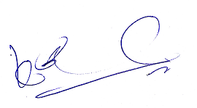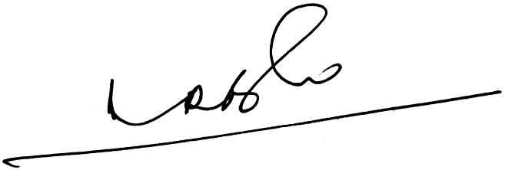  
A Ramesh Babu   K V Acharya,

      Joint Conveners (CBPRO)