A.Ramesh Babu K.V.Acharya
Joint Convener Joint Convener,
Flat No 1103, Block 3B, J-208 Vijay Rattan Vihar,
S.M.R. Vinay Fountainhead, Sector 15, Part II,
Culvary Temple Road, Gurugram -122001
Hyderabad 500 049 Mobile: 09868220338
Mobile: 09849381995 E-mail: acharyavedavyasa46@gmail.com
E-mail: babu2609@gmail.com
__________________________________________________________________________________
Circular 014/2017 Dated 23.08.2017
To
General Secretaries of all Constituents of CBPRO

Dear Comrades,

Sub: 100% D.A. Neutralization case in Supreme Court of India

We refer to our Circular no. 013/2017 dated 14.08.2017 advising that the review in the above case would be heard in the Open Court on 23.8.2017. Accordingly the matter came up for hearing before the Hon’ble Supreme Court on 23.08.2017. Senior Advocate Mr. V K Bali who argued the case on behalf of Retirees during the United Bank of India appeal made a submission to the Bench assuring the Hon’ble Court of his help in the event of need for any clarification. The Hon’ble Court then heard the arguments of Bank Managements represented by their lawyers. The Retirees and their organizations were represented by Senior Advocates Mrs. V Mohana, Mr. R. Viduthalai and Advocates Mr. Sewaram and Mr. SBC Karunakaran.

Com K.S.Rengarajan President, ARISE, Com. K.V.Acharya and Com. D.K.Hans were present in the court. Com. B. Ramji, General Secretary, IOBRA was also present.

Hon’ble Court after hearing the arguments of all the parties reserved the Judgment directing the parties to file written submissions within a weeks’ time.

As a follow-up measure we shall ensure filling of written statements on our behalf within the stipulated period of one week.

We shall keep you posted of the developments.

Yours Comradely,
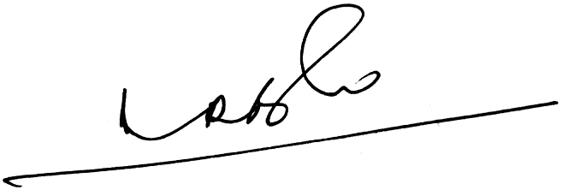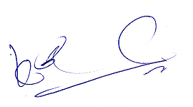
A.Ramesh Babu K.V.Acharya
Joint Conveners

