A.Ramesh Babu K.V.Acharya
Joint Convener Joint Convener,
Flat No 1103, Block 3B, J-208 Vijay Rattan Vihar,
S.M.R. Vinay Fountainhead, Sector 15, Part II,
Culvary Temple Road, Gurugram -122001
Hyderabad 500 049 Mobile: 09868220338
Mobile: 09849381995 E-mail: acharyavedavyasa46@gmail.com
E-mail: babu2609@gmail.com
__________________________________________________________________________________
Dated: 17.08.2017
Circular
Dear Comrades,
Sub: Pending Issues of Bank Pensioners and Retires.
We had advised the latest positions on the above issues to our constituents vide our circular no. 011/2017 dated 03.08.2017. Our circular was well received for its intent and content.
At a later stage there were varied reactions in the social media more particularly after ‘The Hindu Business Line’ reported the matter on 09.08.2017 by attributing their news to Com. Suprita Sarkar acting General Secretary of AIBPARC. It is clarified that Com. Sarkar did not have any dialogue or interview with the reporter of the ‘Business Line’ and the denial has been officially communicated to the reporter. Com. Sarkar did not also issue any press release. We therefore feel that the news wrongly attributed to Com. Sarkar is a closed issue. Though, of course controversial messages in social media did not do any good.
We would however like to advise our comrades that we as a responsible organisation have been making honest and sincere efforts at various levels of authorities and have been faithfully and truthfully reporting the progress and developments from time to time and our circular dated 03.08.2017 was issued in all good faith.
We understand that the AIBRF has issued a circular on 10.08.2017 the contents of which are at variance with those of our circular dated 03.08.2017. In this connection we wish that AIBRF as an organisation of Retirees, intermittently expressing its desire in its communications for a broader coordination which are well responded by us, should have made efforts to seek further details on the contents of our circular to avoid confusion amongst the members and negate the efforts of all the organisations of Bank Pensioners and Retirees. A reference to the sub-committee constituted by IBA in the circular of AIBRF is only a matter of record and we had already mentioned about the meeting of UFBU with the Chairman of the Sub-Committee of IBA on 01.08.2017 itself.

While reiterating our commitment to continue to work for the resolution of the pending issues of the Bank Pensioners and Retirees to the best of our ability by marshalling all the resources at our command, we request all the comrades and Retirees’ organisations to stand united and strengthen the Bank Pensioners and Retirees movement.

Yours Comradely,
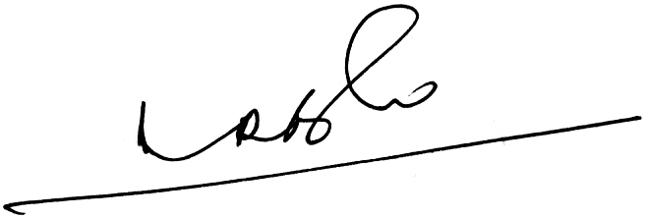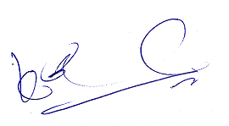
A.Ramesh Babu K.V.Acharya
Joint Conveners

