**A.Ramesh Babu K.V.Acharya**

**Joint Convener Joint Convener,**

**Flat No 1103, Block 3B, J-208 Vijay Rattan Vihar,**

**S.M.R. Vinay Fountainhead, Sector 15, Part II,**

**Culvary Temple Road, Gurugram -122001**

**Hyderabad 500 049 Mobile: 09868220338**

**Mobile: 09849381995 E-mail: acharyavedavyasa46@gmail.com**

**E-mail:** [**babu2609@gmail.com**](mailto:babu2609@gmail.com)

**_____________________________________________________________________________________**

**Dated: 08.12.2017**

**Shri Arun Jaitleyji,**

**Hon’ble Finance Minister,**

**Government of India,**

**Ministry of Finance,**

**North Block, New Delhi 110001**

Respected Sir,

**Union Budget 2018-19**

**Income Tax exemption on Pension**

We wish to introduce ourselves as a Coordination of five major National Organisations of Bank Pensioners and Retirees namely Federation of SBI Pensioners’ Associations, AIBPARC, RBONC, AIRBEA and FORBE, having more than 4 lacs membership.

The Senior Citizens above the age of sixty are extended the benefit of Rs. 50,000.00 in the threshold limit exempt from payment from income tax up to a ceiling of Rs. 300,000.00 as against Rs. 250,000.00 for others. The Retirees being the Senior Citizens have been expressing financial hardship mainly on account of rising cost of sustenance, healthcare, price rise etc. The Senior Citizens have been very severely hit by adverse movement of interest rates on their small savings and Bank deposits. In a developing economy, such adverse indicators are bound to hit the fixed income group people more so the Senior Citizens. The impact on Family Pensioners gets compounded in view of the meagre amount of Family Pension drawn by them.

We therefore humbly request Your Good-self to consider complete exemption from payment of Income Tax to Pensioners and Retirees to the extent of their income from Pension and interest on Small Savings and Bank Deposits. While providing succour to Senior Citizens, such an exemption shall go a long way to further enhance the goodwill and image of the Government of the day amongst the Senior Citizens of the country.

Kindly do the needful in the ensuing budget.

With respectful regards,

Yours sincerely,

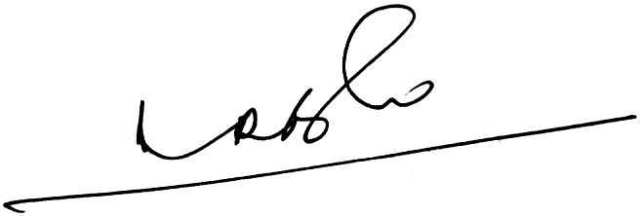 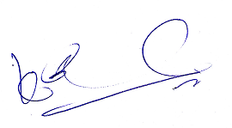

**A.Ramesh Babu K.V.Acharya**

**Joint Conveners**