A.Ramesh Babu K.V.Acharya
Joint Convener Joint Convener,
Flat No 1103, Block 3B, J-208 Vijay Rattan Vihar,
S.M.R. Vinay Fountainhead, Sector 15, Part II,
Culvary Temple Road, Gurugram -122001
Hyderabad 500 049 Mobile: 09868220338
Mobile: 09849381995 E-mail: acharyavedavyasa46@gmail.com
E-mail: babu2609@gmail.com
__________________________________________________________________________________
Dated: 08.12.2017
To
Shri Sanjeev K Bandlish
Convenor, UFBU
General Sectary, NCBE
State Bank of India
Chandigarh

Dear Com. Bandlish,
Issues Relating to Pensioners and Retirees
Negotiation with IBA

We wish to invite your attention to the Record Note dated 25.05.2015 signed by IBA with the representatives of UFBU. We mention the issues contained in the said Record Note for your ready reference:

- LFC and Hospitalisation reimbursement should be extended to Retired Bank Employees/Officers.
- Revision in the rates of Family Pension on the same lines of the Central Government/RBI Scheme.
- Extending Dearness Relief at 100% Compensation to all Pre-November 2002 Pensioners as in the case of post November 2002 Retirees.
- Upgrading the Basic Pension of all the Pensioners at the common and uniformed index of 4440 points.
- Updation of Pension for all the existing Pensioners and Family pensioners.
- Periodical updation/improvement in Pension along with Wage Revision of in-service Employees on the lines of Central Government.
- Uniform percentage of allocation from Welfare Fund towards Schemes pertaining to Retirees.

It may be appreciated that there was categorical and solemn assurance by IBA on the issue of revision of Family Pension rates and 100% Dearness Relief to pre November 2002 Pensioners. Similarlily the issue of upgrading the Basic Pension of all the Pensioners at the common and uniformed index at 4440 points was to be examined by IBA with regard to its cost implication and sustainability of Member Banks.

The views of IBA on all the above issues notwithstanding, the very existence of Record Note stands a mute testimony to the fact that all these issues are negotiable with IBA by UFBU. In this backdrop, the contention of IBA that issues like 100% DA and updation are sub-judice due to litigation is illegitimate and unacceptable as the parties to the dispute in the Court do not include any of the constituents of UFBU. Moreover none of the Courts in the country has issued any order restraining IBA from resolving these issues outside the Court by mutual discussion with UFBU. We therefore reiterate our firm belief that IBA is duty bound to settle all the pending issues pertaining to Retirees. It is pertinent to mention that every serving employee/officer is bound to retire and post superannuation benefits do form part of their service conditions. Hence it is wrong on the part of IBA to show their oblivion and escapist attitude at this juncture.

As is well known, IBA has not provided any official platform or mechanism to the Organisations of Retirees to discuss and settle the issues pertaining to Retirees. Under these circumstances the UFBU is the sole body to negotiate with IBA for resolution of all the issues pertaining to the Retirees. We therefore earnestly request all the constituents of UFBU to reiterate their locus standi and endeavour to resolve all the pending issues of Pensioners and Retirees.

We also wish to inform you that all the above issues have also been taken up by us with the Government of India (DFS) and IBA separately and the same are being pursued by us on a regular basis. With the vibrant leadership of UFBU, we are very confident that IBA will come around and resolve the issues.

Kindly do the needful at your end.

Yours Comradely,
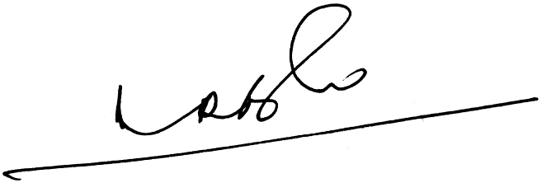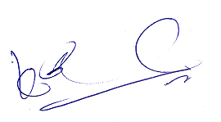
A.Ramesh Babu K.V.Acharya
Joint Conveners

