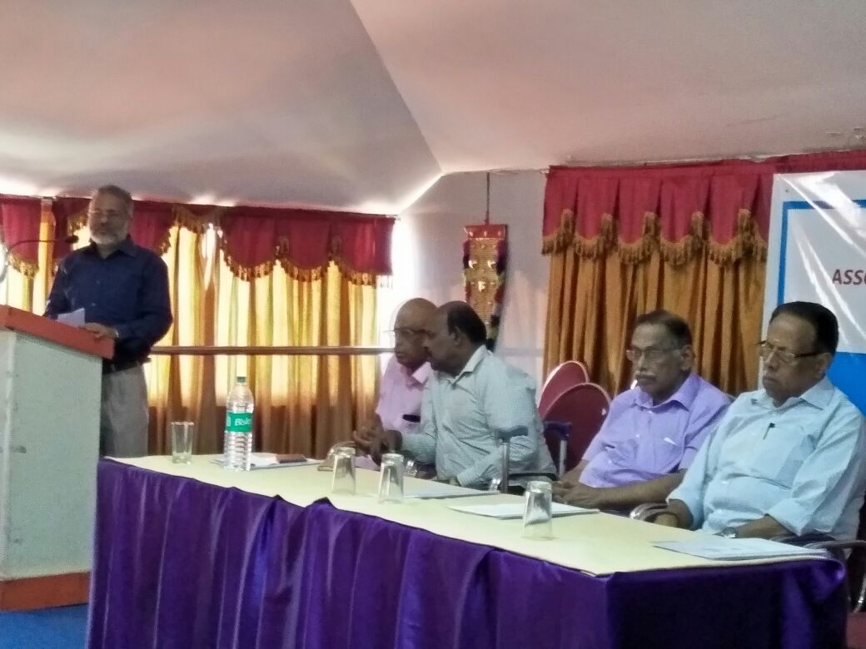

Sri.Abraham Shaji John addressing the Gathering

P Sekharankutty V.Gopina th Gireeshkumar and Ananthapadmanabhan in the diS