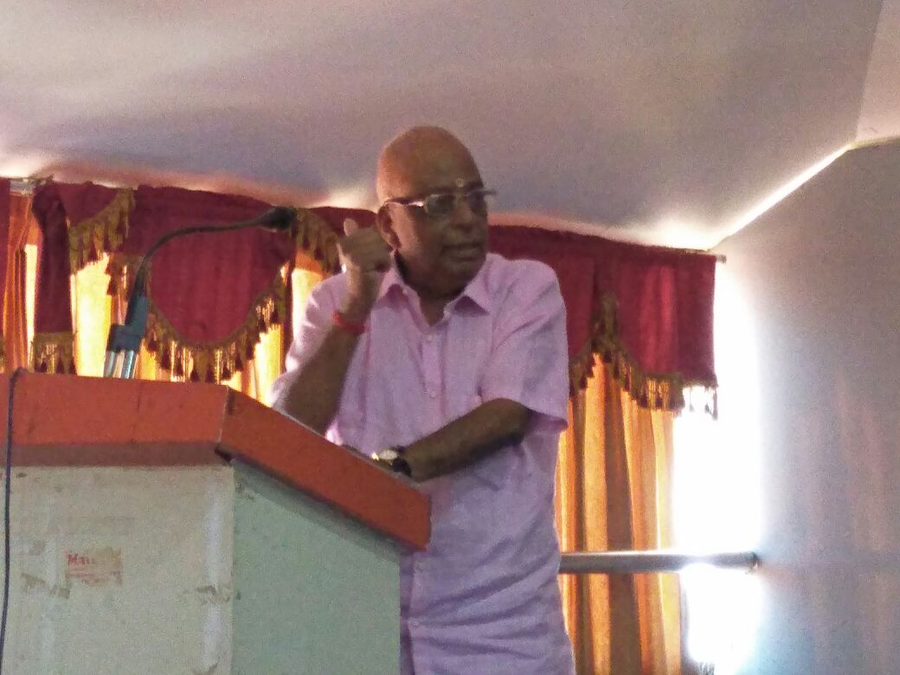

Ananthapadmanabhan K.R. addressing the Gathering.