COORDINATION OF BANK PENSIONERS’ AND RETIREES ORGANISATIONS
Flat No. 1103, Block-3B, S.M.R. Vinay Fountainhead, Culvary Temple Road,
Hydernagar, Hyderabad – 500 049.
__________________________________________________________________________________
Joint Convener Joint Convener,
Flat No 1103, Block 3B, J-208 Vijay Rattan Vihar,
S.M.R. Vinay Fountainhead, Sector 15, Part II,
Culvary Temple Road, Gurgaon 122001
Hyderabad 500 049 Mobile: 09868220338
Mobile: 09849381995 E-mail: acharyavedavyasa46@gmail.com
E-mail: babu2609@gmail.com
_____________________________________________________________________________________________
Circular No. 002/2018 Dated: 17.01.2018

Dear Comrades,

100% DA CASE IN HON’BLE SUPREME COURT
The retiree Bank Officers of Pre-2002 were meted out an unfair treatment by arbitrarily denying them the benefit of 100% DA. The issue was agitated before the Hon’ble Courts seeking judicial recourse. It finally landed before the Hon’ble Supreme Court of India. The Hon’ble Court has heard the arguments of all the parties to the case and reserved the Judgement. We have been hoping for a favourable judgement so as to get necessary relief to Pre-2002 retirees.

We have been in regular contact with the Senior Advocates who had argued our case before the Hon’ble Supreme Court. We understand that sometimes it takes little longer for the reserved Judgments to be pronounced by the Hon’ble Court. We therefore would like to assure our Comrades that we are conscious of their anxiety and concerns. Let us wait for an early relief.

We wish and hope for a favourable and early pronouncement of reserved Judgement.

OTHER PENDING ISSUES:

All other pending issues relating to Bank Pensioners and Retirees are being followed up with Department of Financial Services, Ministry of Finance, Government of India by us. We hope that some of the issues will get resolved early. We shall work tirelessly for the cause of Bank Pensioners and Retirees.

We note to keep you posted of the developments in this regard.

NEW YEAR GREETINGS:

While extending our Warm Greetings for a Happy, Healthy & Fruitful NEW YEAR 2018 to our Comrades and their family members, we hope that NEW YEAR would augur well for working class and also for the Bank Pensioners and Retirees. We request our Comrades to work for strengthening the Bank Pensioners and Retirees movement.

“Victory shall be Ours”

With Regards
Yours Comradely,

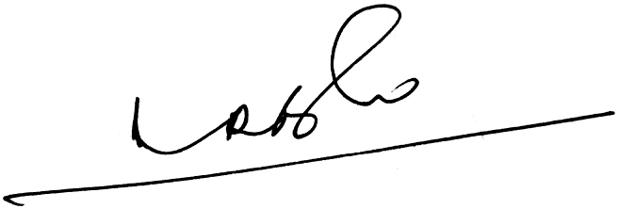
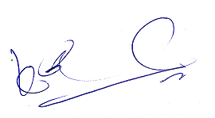
A Ramesh Babu K V Acharya,
Joint Conveners (CBPRO)

