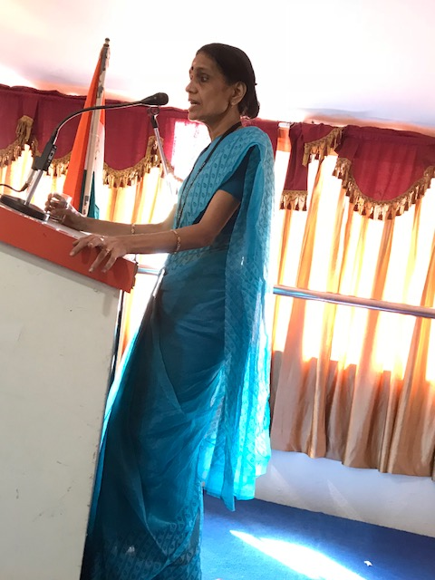

Dr.Kalavathy Regional CancervvCentre Trivandrum addressing theaudiance.