**Joint Convener Joint Convener,**

**Flat No 1103, Block 3B, J-208 Vijay Rattan Vihar,**

**S.M.R. Vinay Fountainhead, Sector 15, Part II,**

**Culvary Temple Road, Gurgaon 122001**

**Hyderabad 500 049 Mobile: 09868220338**

**Mobile: 09849381995 E-mail: acharyavedavyasa46@gmail.com**

**E-mail:** [**babu2609@gmail.com**](mailto:babu2609@gmail.com)

**__________________________________________________________________________________**

**Circular No. 001/2018 Dated: 14.01.2018**

Dear Comrades,

**LEGENDARY ‘SANTI DA’ IS NO MORE**

Comrade S. R. Sengupta fondly and popularly known as SANTI DA breathed his last at Kolkata in the early hours today i.e. 14th January 2018 which happens to be the Makarsakranti day. His sudden and sad demise has left us all in grief.

Com. Santi Da has been a legendary trade unionist who spearheaded the Bank Officers’ movement for decades. Apart from being the General Secretary of the Federation of Bank of India Officers’ Associations, he was Vice President of AICOBOO before giving birth to All India Bank Officers’ Confederation (AIBOC) in the year 1985. Com. Santi Da was the founder President of AIBOC along with Com. R. N. Godbole as its General Secretary. He was unanimously elected as General Secretary of AIBOC on superannuation of Com. Godbole. AIBOC grew in strength and stature during the stewardship of Santi Da.

Santi Da has been a champion of Bank Officers’ movement and after superannuation from the services of Bank of India, he started an organization viz Foundation of United Trade Union Research & Education (FUTURE). The publications of FUTURE were of great significance and contained valuable information for the readers.

The welfare of Bank Pensioners and Retirees was very dear to Santi Da and it ignited a spark in AIBOC to come forward and sponsor an umbrella organization for Bank Pensioners and Retirees. With this was born All India Bank Pensioners and Retirees Confederation (AIBPARC) which was sponsored by AIBOC and Santi Da was unanimously elected as its General Secretary in the foundation conference at Delhi. He continued to be the General Secretary of AIBPARC till he breathed his last.

The loss of such an illustrious leader has left us all grief-stricken. His contributions to Bank Officers’ movement and also to the Bank retirees’ movement shall ever remain etched in golden letters and shall be cherished by us for long time to come. Comrades as a mark of our love, respect and admiration for Santi Da we take a pledge to emulate the value based principles of which he was a crusader.

We also take this opportunity to convey our heartfelt condolences to the bereaved family of Santi Da and pray almighty to bestow enough strength and courage to bear the irreparable loss.

**“Long Live Santi Da”**

**“Red Salute Santi Da”**

**CBPRO dips its banner as a mark of respect to the departed soul.**

Yours Comradely,

**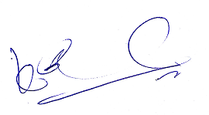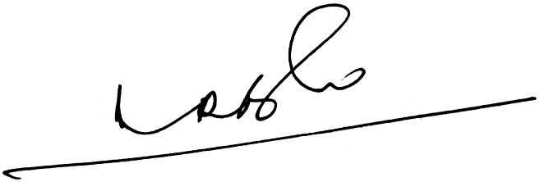  
A Ramesh Babu   K V Acharya,**

**Joint Conveners (CBPRO)**