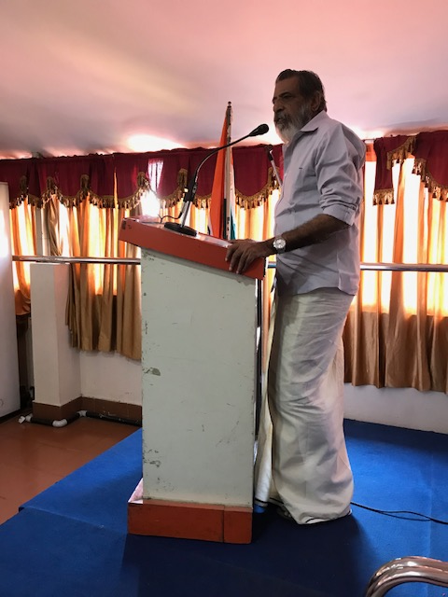

Mr.Vijayakumaran Nair Rajeswary foundation addressing the fathering.