**A.Ramesh Babu K.V.Acharya**

**Joint Convener Joint Convener,**

**Flat No 1103, Block 3B, J-208 Vijay Rattan Vihar,**

**S.M.R. Vinay Fountainhead, Sector 15, Part II,**

**Culvary Temple Road, Gurgaon 122001**

**Hyderabad 500 049 Mobile: 09868220338**

**Mobile: 09849381995 E-mail: acharyavedavyasa46@gmail.com**

**E-mail:** [**babu2609@gmail.com**](mailto:babu2609@gmail.com)

**____________________________________________________________________________________**

**Dated: 03.02.2018**

**Ms Usha Ananthasubramanian**

**Chairman, IBA**

**MD & CEO**

**Allahabad Bank**

**2, Netaji Subhash Road**

**KOLKOTA 700 001**

Respected Madam,

**HEARTIEST GREETINGS ON YOUR BECOMING  CHAIRMAN OF IBA**

We firmly believe that holding the position of the Chairman, Indian Banks' Association, is a matter of great pride for any banker. This position has been adorned by many bankers of repute and distinction in the history of IBA. But you are singularly privileged to occupy this position of repute as a first **WOMAN** banker. It gives us a great sense of pride at a time when there is quite a significant emphasis and focus on women empowerment in our country.

We take this opportunity to extend our heartiest greetings on your becoming the Chairman of Indian Banks' Association. You have taken the reins of the prestigious body of the banks at a very crucial juncture. We are confident that your professional skills and rich experience acquired during your tenures at Bank of Baroda, Punjab National Bank, Bharatiya Mahila Bank and Allahabad Bank will come in handy to make this challenging task easy. We also consider your assignment very important as the salary revision of the bank  employees and officers is also in the process of negotiation and your pragmatic approach will certainly help in making it good enough to attract the required talent from the market so as to manage this most vital sector of the economy more effectively.

We too, as the elders, having served the banking industry for several decades nurture a fond hope that the pending issues of the retirees will also get your kind attention for an early resolution.

Respected Madam, we wish you very best and success in your new assignment.

Yours faithfully,

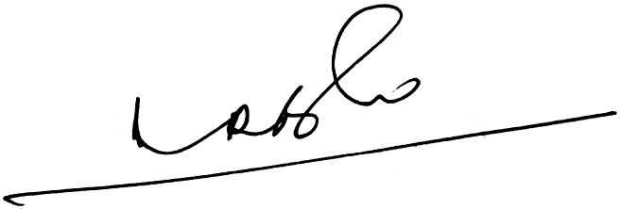 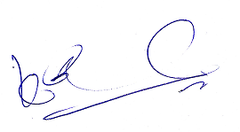

**A.Ramesh Babu K.V.Acharya**

**Joint Conveners**