**A.Ramesh Babu K.V.Acharya**

**Joint Convener Joint Convener,**

**Flat No 1103, Block 3B, J-208 Vijay Rattan Vihar,**

**S.M.R. Vinay Fountainhead, Sector 15, Part II,**

**Culvary Temple Road, Gurgaon 122001**

**Hyderabad 500 049 Mobile: 09868220338**

**Mobile: 09849381995 E-mail: acharyavedavyasa46@gmail.com**

**E-mail:** [**babu2609@gmail.com**](mailto:babu2609@gmail.com)

**____________________________________________________________________________________**

**CBPRO CIRCULAR Dated: 31.01.2018**

Dear Comrades,

**COM. R.N. BANERJEE PASSED AWAY.**

**RESPECTFUL TRIBUTES.**

It is with deep sense of grief and sorrow, we pen down the news of the sad demise of our beloved Chairman, **CBPRO**, Com R N Banerjee Sir, who also held the post of President of Federation of SBI Pensioners’ Associations and was the founder General Secretary of Bengal Circle SBIOA. We have lost a Crusader of Bank Pensioners and Retirees in his sad demise. His departure leaves a huge void in the leadership of the organisations Com Banerjee was spearheading. We never thought that his end would come so soon though he was suffering from a serious ailment - “Blood Cancer” for the past three decades. Such a serious ailment also could not prevent him from serving the membership. This is a reflection of his strong persona and zeal to serve his comrades.  We dip our banner in his memory as a mark of our deepest sense of respect to the departed soul.

Com Banerjee was a bright alumnus of Allahabad University and joined State Bank of India as Probationary Officer on 01.03.1961. He plunged into the officers’ movement at the very early stage of his career and ultimately became the General Secretary of State Bank of India Supervising Staff Association, since renamed as S.B.I. Officers’ Association. It was under his stewardship that the officer community in SBI organized several agitations including the historic indefinite Strike of Work in the year 1969.  The very fact that he rose to the position of General Manager in the career hierarchy of the bank, stands a mute testimony  of his skills and merits as an industrious officer of the bank. He also had the distinction of being deputed to West Bengal Financial Corporation as its Managing Director apart from being posted to different foreign offices of the Bank.

After his retirement he joined the Pensioners’ Association in Bengal Circle in the year 2001. His commitment to the cause of the pensioners made him the natural choice for the position of General Secretary at Circle level and later on President, Federation of SBI Pensioners’ Associations in the year 2015. He will also be remembered as an architect of unity of pensioners’ organisations in the Banking Industry. It is his initiative, which was instrumental in bringing the organisations of Bank Pensioners and Retirees together under the umbrella of **CORDINATION OF BANK PENSIONERS’ AND RETIREES ORGANISATIONS (CBPRO)**.  A devout perfectionist, a man with profound knowledge, charming oratory and a facile pen, Com. Banerjee was loved by all in the pensioners’ fraternity in the Banking Industry.

 It may appear unbelievable to many despite the serious ailment Com Banerjee never failed in his duties and travelled distant places to meet his organizational commitments untiringly. Ultimately he had to surrender to the will of the Almighty by breathing his last at 12-15pm on Monday, the 29th January 2018 in the presence of his wife, daughter and granddaughter at Santiniketan, Bolpur, a place far from the maddening crowd of the metropolis of Kolkata.

While praying for eternal peace for the departed soul, we convey our heartfelt condolences to the members of the bereaved family.

Com. R.N. Banerjees’s indomitable spirit and inspiring leadership will continue to guide us to take the Bank Retirees Movement forward with further consolidation.

**MAY COM. R.N. BANERJEE SIR’S SOUL REST IN PEACE.**

Yours Comradely,

**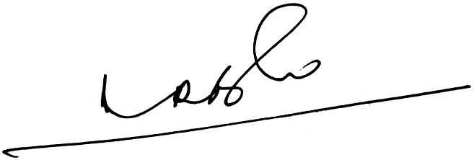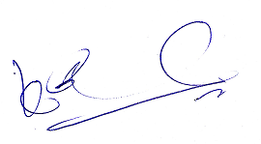  
A Ramesh Babu   K V Acharya,**

**Joint Conveners (CBPRO)**