A.Ramesh Babu K.V.Acharya
Joint Convener Joint Convener,
Flat No 1103, Block 3B, J-208 Vijay Rattan Vihar,
S.M.R. Vinay Fountainhead, Sector 15, Part II,
Culvary Temple Road, Gurgaon 122001
Hyderabad 500 049 Mobile: 09868220338
Mobile: 09849381995 E-mail: acharyavedavyasa46@gmail.com
E-mail: babu2609@gmail.com
_________________________________________________________________________
CBPRO Circular No: 006/2018 Dated: 07.03.2018

Dear Comrades,

Supreme Court Judgment on Re-fixation of Basic Pension and payment of arrears for those retired between April 1998 and October 2002.

In continuation of our Circular No. 005/2018 dated 14.02.2018, we are pleased to advise that the Hon’ble Supreme Court has been gracious in considering the issues raised by the affected Pensioners who filed various petitions challenging the settlement which deprived those who Retired between 1st April, 1998 and 31st October, 2002 full Pension @ 50% of their last drawn Basic Pay. The Hon'ble Supreme Court in its judgment pronounced by Hon’ble Justice Mr. Arun Mishra and Hon’ble Justice Mr. Amitava Roy on 13th Feb 2018 restored the same as per Pension Regulations 2(d), 35(2), 38(1) and 38(2) and ordered payment of arrears for those who retired during the above period with interest at 9% within four months from the date of the order.

For the benefit of our members we wish to state that in the wage settlement of 1998 the merger point of DA was irrationally fixed at 1616 points for the purpose of fixing the Basic Pension to the Retirees of the relevant period where as for the serving employees and Officers it was fixed at 1684 points. This reduced the Basic Pension to about 41% of the last drawn Basic Pay instead of 50% of the last drawn Basic Pay as per the Bank Employees’ Pension Regulations 1995.

The Hon’ble Supreme Court held that there cannot be two different Pay scales one for the purpose of calculating Pension and other one for the purpose of calculating Salary. It also observed that Joint Note/Award made under the Industrial Disputes Act 1947 cannot be inconsistent with the law laid by the legislature or by the Supreme Court and if it does so it is illegal and cannot be forced.

The Hon’ble Supreme Court of India in its order dated 13th February 2018 in case of Bank of Baroda and ANR v/s G. Palani and ORS while setting aside the Judgment rendered by the Hon’ble High Court of Delhi also affirmed the Judgments of Hon’ble High Court of Karnataka at Bangalore and the Hon’ble High Court of Madras has also upheld the following principles with regard to Pensioners:

- The Bank Employees’ Pension Regulations having been framed in exercise of powers conferred by Section 19 of Banking Companies (Acquisition and Transfer of Undertakings) Act 1970 have statutory force and are binding. These Regulations could not be supplanted or over-ridden by any executive fiat or order which has no statutory basis.
- The interpretation of any Regulation as per deeming fiction is wholly impermissible and it is not permissible to add or subtract any word in a provision in view of the settled principles of statutory interpretation.
- Pension is not a bounty or charity or gratuitous payable on the sweet will and pleasure of the Government.
- Right to Pension is a valuable right vested in a Government Employee and cannot be dealt with arbitrarily.
- Right to receive Pension is property under the Act and Article 19 of the Constitution.
- Pension is a deferred portion of compensation for the past service and is in the nature of social security to provide for the December (Evening) of life of a Retired Employee.
- While a benefit can be given with retrospective effect, no Settlement or Award can withdraw the existing benefit with retrospective effect. Taking away a benefit already available to the Employees under existing rules is arbitrary, discriminatory and violative of rights granted under Articles 14 and 16 of the Constitution.
- The Pension is closely akin to wages in that it consists of payment provided by an Employer, is paid in consideration of past service and serves the purpose of helping the recipient to meet the expenses of living.
- A Joint Note or Award cannot create estoppel as against the enforcement of statutory provisions contained in the Pension Regulations.

The Hon’ble Supreme Court in para 33 of its judgment emphatically stated that it had no hesitation to strike down the explanation (c) to Regulation 2(s) being arbitrary and repugnant to the provisions of Regulations 2(d), 35, 38(1) and 38(2) as its purpose was to take away the actual computation of the pension on the basis of the salary which was drawn in preceding ten months.

We place on record our deep sense of appreciation to the comrades of Bank of Baroda and others who challenged the above provision of the wage settlement arguing that this would amount to violation of Bank Employees’ Pension Regulations 1995. The endurance and determination to fight against arbitrary and illegal explanation to the provisions of Pension Regulations 2(s) deserves all commendation. This is one more instance of display of irrationality and illegality by the IBA through a wage settlement which is again now SET ASIDE by the Hon'ble Supreme Court.

We thank and congratulate Bank of Baroda Retired Officers Association (Affiliated to RBONC) who spearheaded writ petitions by impleading and actively associating in taking up the issue both in Hon’ble High Court and Hon’ble Supreme Court.

We also thank and congratulate Com. K S Rengarajan, President Arise-IOB (affiliated to AIBPARC) for filing the writ petitions along with others in the Hon’ble High Court of Madras where they got favorable judgment on the same issue.

We advise our members that we have taken up with IBA for immediate implementation of the order of the Hon’ble Supreme Court of India and grant the benefit to the affected Retirees in all the Banks by making payment of arrears along with interest @ 9% as ordered by the Hon’ble Court.

With Comradely Regards,

Yours Comradely,
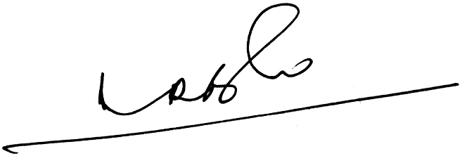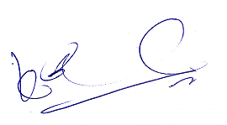
A.Ramesh Babu K.V.Acharya
Joint Conveners

