A.Ramesh Babu K.V.Acharya
Joint Convener Joint Convener,
Flat No 1103, Block 3B, J-208 Vijay Rattan Vihar,
S.M.R. Vinay Fountainhead, Sector 15, Part II,
Culvary Temple Road, Gurgaon 122001
Hyderabad 500 049 Mobile: 09868220338
Mobile: 09849381995 E-mail: acharyavedavyasa46@gmail.com
E-mail: babu2609@gmail.com
_________________________________________________________________________________________
Dated: 07.03.2018
Shri V G Kannan
Chief Executive,
Indian Banks’ Association
Mumbai.

Respected Sir,

Request for implementation of the judgment dated 13.02.2018 of the Hon’ble Supreme Court in respect of those who retired between April 1998 and October 2002.

We are glad to bring to your kind knowledge that the various petitions filed by our Retiree Comrades challenging the provisions of settlement which led to redefining the average emoluments by simply amending and adding explanation (c) in Regulation 2(s) thus adversely affecting those Pensioners who retired between 01.04.1998 and 31.10.2002 have been disposed off by the Hon’ble Supreme Court vide its order dated 13.02.2018 by setting aside the illegal and arbitrary provisions. The Hon’ble Supreme Court has struck down the provisions of explanation (c) to Regulation 2(s) as it took away the actual computation of the Pension on the basis of the salary drawn in the preceding ten months and was also arbitrary and repugnant to the provision of Regulations 2(d), 35, 38(1) and 38(2).

The order of the Hon’ble Supreme Court entitles all those Retirees who retired between 01.04.1998 and 31.10.2002 for re-fixation of their Basic Pension and payment of arrears along with interest @ 9% within the time specified in the order. We therefore request you to issue suitable instructions to all the Member Banks for payment of arrears along with interest to such Retirees.

We also take this opportunity to request you to settle our other pending issues including updation of Pension in terms of Regulation 35(1) as the Hon’ble Supreme Court has held that the implementation of Pension Regulations being statutory in nature is the obligation of the Employers.

With regards,

Yours sincerely
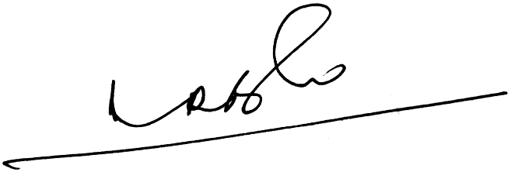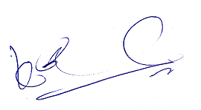
(A.Ramesh Babu) (K.V.Acharya)
Joint Conveners CBPRO

