A.Ramesh Babu K.V.Acharya
Joint Convener Joint Convener,
Flat No 1103, Block 3B, J-208 Vijay Rattan Vihar,
S.M.R. Vinay Fountainhead, Sector 15, Part II,
Culvary Temple Road, Gurugram 122001
Hyderabad 500 049 E-mail: acharyavedavyasa46@gmail.com
E-mail: babu2609@gmail.com Mobile: 09868220338
Mobile: 09849381995 __________________________________________________________________________________
Dated: 11.04.2018
To
Shri Sanjeev K Bandlish
Convenor, UFBU
C/o State Bank of India
Chandigarh

Dear Com. Bandlish,

Medical insurance Scheme - Constitution of Committee Proposed by IBA

We refer to the telephonic talk with you on 10th April 2018.

You are aware that the Retirees have been agitating against the discriminatory treatment with regard to payment of premium, coverage of the Scheme, reimbursement under domiciliary (OPD) treatment, dental care etc. We have been receiving numerous representations from individual Retirees and also the Associations of Retirees in this regard. We have therefore been demanding that IBA should bring about improvements in the Medical Insurance Scheme for Retirees so as to make it at par with the Scheme for Serving Employees in all respects.

You will appreciate that DFS letter dated 24.02.2012 advising IBA to formulate Medical Insurance Scheme both for Serving Employees and Retirees did not stipulate any condition with regard to payment of premium by the retirees or the coverage/ scope of the Scheme. It will therefore be just and fair if the Medical Insurance Scheme for Retirees is rationalised by removing the discriminatory provisions from the Scheme.

We understand that IBA intends to constitute a committee consisting of General Managers and the nominees of UFBU Representatives so as to examine the intricacies in the Insurance Scheme and suggest further improvements. In this background CBPRO representing five major Apex Organisations with a membership of more than 400,000 Retirees requests that due consultations should be held with us also in respect of Retirees’ grievances and expectations. We shall be obliged if you could use your Good Offices to ensure our participation in the proposed discussions. We are making a similar request to IBA in this regard.

With regards,

Yours Comradely,
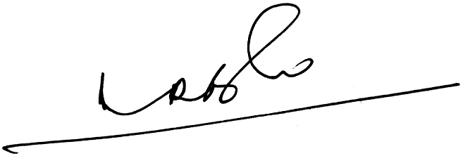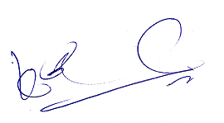
A.Ramesh Babu K.V.Acharya
Joint Conveners

