A.Ramesh Babu K.V.Acharya
Joint Convener Joint Convener,
Flat No 1103, Block 3B, J-208 Vijay Rattan Vihar,
S.M.R. Vinay Fountainhead, Sector 15, Part II,
Culvary Temple Road, Gurugram 122001
Hyderabad 500 049 E-mail: acharyavedavyasa46@gmail.com
E-mail: babu2609@gmail.com Mobile: 09868220338
Mobile: 09849381995 __________________________________________________________________________________
Dated: 11.04.2018

Shri V G Kannan,
Chief Executive,
Indian Banks’ Association,
Mumbai

Dear Sir,

Medical Insurance Scheme for Retired Bank Employees and Officers

We have been demanding parity with serving employees with regard to absorption of the premium by the Banks on the following grounds:

- DFS letter dated 24.02.2012 advised IBA to formulate Medical Insurance Scheme both for Serving Employees and Retirees without stipulating any condition with regard to payment of premium by the Retirees.

- Retired CMDs/MDs/EDs are allowed benefit of Medical Scheme at par with Serving CMDs/MDs/EDs without payment of any premium by them.

- In many Banks a scheme for Retirees existed in the name and style of RETIRED EMPLOYEES MEDICAL ASSISTANCE SCHEME wherein the Bank provided Medical Insurance after collecting one time contribution.

- The Medical Insurance Scheme introduced by IBA should logically be on similar lines as available to the Serving Employees and full premium borne by the Banks.

The retirees have been agitating against the discriminatory treatment with regard to the payment of premium, coverage of the scheme, reimbursement under domiciliary (OPD) treatment, dental care etc. Like IBA, we also have been receiving numerous representations from individuals and the Associations of Retirees. The issues raised by us in our earlier communications to IBA call for immediate resolution.

We understand that IBA has been taking up the issue of review of Medical Insurance Scheme with UFBU soliciting their nomination for a committee to be constituted with the participation of General Managers and UFBU representatives so as to examine the intricacies of the Scheme and further improvements.

At the outset we hugely appreciate the concern exhibited by IBA in understanding the grievances of Retirees pertaining to the scope, implementation, payment of premium etc. and initiating the process of redressal of the grievances/suggesting further improvements. We are confident that this noble initiative by IBA shall go a long way in making the Banks Retiree Friendly Organisations.

We, as Coordination of five major Apex Organisations of Retirees having more than 400,000 members, are of the considered view that most of the grievances about the Medical Insurance Scheme pertain to the Retirees and hence it is very essential to have discussion and consultation with us as the Coordinated Body of Apex Retirees’ Organisations.

We hope our concerns will be appreciated and our request for discussion and consultation will be considered.

Thanking you,

Yours faithfully
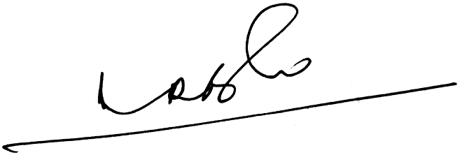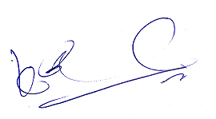
A.Ramesh Babu K.V.Acharya
Joint Conveners

