A.Ramesh Babu K.V.Acharya
Joint Convener Joint Convener,
Flat No 1103, Block 3B, J-208 Vijay Rattan Vihar,
S.M.R. Vinay Fountainhead, Sector 15, Part II,
Culvary Temple Road, Gurugram -122001
Hyderabad 500 049 E-mail: acharyavedavyasa46@gmail.com
E-mail: babu2609@gmail.com Mobile: 09868220338
Mobile: 09849381995
__________________________________________________________________________________
Circular No: 010/2018 Dated: 16.05.2018

TO
THE GENERAL SECRETARIES
Constituents of C B P R O

Dear Comrades,

Sub: Honourable Supreme Court Judgement regarding 100% DA Neutralisation.

The long awaited Judgement in respect of the above has been ultimately pronounced today.

With deep regret we have to convey to our members and to all those Pre-2002 Retirees that the Hon’ble Supreme Court allowed the appeal of United Bank of India management thereby denying the parity of DA to Pre-November 2002 Retirees vis-a-vis the Post November 2002 Retirees. Since the issues raised in the Civil Appeal/Review Petition filed by R Balakrishna Bhat, C R Chandrasekharan and T V Alwan of BOB, IOB & Canara Bank respectively were similar to that arising in United Bank of India case, these Civil Appeals/Review Petitions are dismissed in terms of Hon’ble Supreme Court judgement rendered in the case of United Bank of India today.

We had lot of confidence to WIN this case after witnessing the final arguments by our advocates, but our hopes are dashed. We understand the pain of the members who are deprived of their well deserved entitlements. We whole heartedly empathise and sympathise with the aggrieved members.

While assuring the members of our best efforts to explore other alternatives, we note to issue a detailed circular after studying and analysing the full judgement of the Hon’ble Supreme Court.

We once again express our sincere concern and deep shock in the matter.

Yours Comradely,

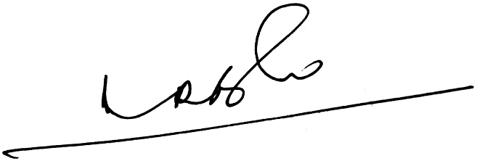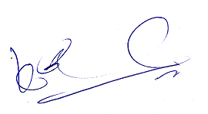
A.Ramesh Babu K.V.Acharya
Joint Conveners

