A.Ramesh Babu K.V.Acharya
Joint Convener Joint Convener,
Flat No 1103, Block 3B, J-208 Vijay Rattan Vihar,
S.M.R. Vinay Fountainhead, Sector 15, Part II,
Culvary Temple Road, Gurugram -122001
Hyderabad 500 049 E-mail: acharyavedavyasa46@gmail.com
E-mail: babu2609@gmail.com Mobile: 09868220338
Mobile: 09849381995 _________________________________________________________________________
Dated: 15.05.2018

Shri Sanjeev K Bandlish
Convenor
UFBU
C/o SBI, LHO,
Chandigarh 160017

Dear Com. Bandlish,

PENDING ISSUES OF RETIREES

We appreciably refer to your circular dated 10.05.2018 proposing an agitation programme including 2 days strike call on 30th and 31st May 2018. In this connection we pledge our wholehearted support to all your action programmes and assure our active participation in Dharnas, Rallies, Demonstrations etc. to be conducted at different centres throughout the Country. We shall advise all our constituents to ensure large scale participation by the Retirees in your action programmes.

We refer to our letter dated 05.04.2018 to you wherein we had also suggested a coordinated action plan including 2 days strike in the month of May 2018. We firmly believe that today’s serving employees shall be
tomorrow’s Retirees. The trade unions in the Banking Industry believing in this philosophy have always been taking up the issues of Retirees with IBA and the impending charter of demands including the issues of retirees is a testimony to this effect. It is also pertinent to recollect that IBA and UFBU signed a RECORD NOTE at the time of signing of last Bipartite Settlement on 25th May 2015. We request you to effectively pursue with IBA the pending issues of Retirees as per the said record note and also demand Medical facility for Retirees as available to serving employees. It would therefore be desirable that the pending issues of Retirees are also highlighted not only to IBA but also in all action programmes of UFBU. We request you to do the needful and advise all the constituents of UFBU in this regard.

While looking forward for a favourable response, we once again pledge our wholehearted support to all the action programmes of UFBU.

With regards

Yours Comradely,
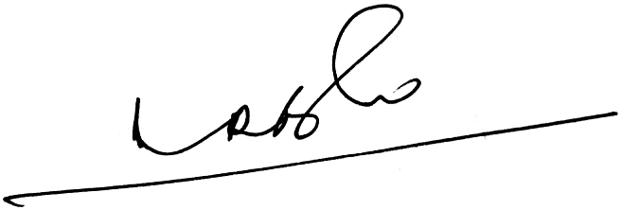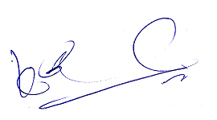
A.Ramesh Babu K.V.Acharya
Joint Conveners

