Dated: 09.06.2018

To

Com. Sanjeev K. Bandlish

Convenor

U.F.B.U.

Dear Comrade

**100% D.A. NEUTRALISATION TO PRE-NOVEMBER 2002 PENSIONERS & IMPROVEMENT IN FAMILY PENSION SCHEME @ 30% OF BASIC PAY**

We wish to invite your kind reference to the Record Note dated 25.05.2015 between IBA and UBFU constituents wherein the pending issues of retirees were listed along with the response of IBA. The response of IBA in respect of these two issues is furnished below for a ready reference:

1. **100% D.A. NEUTRALISATION TO PRE-NOVEMBER 2002 PENSIONERS**

**IBA’s response:** “the matter is sub judice as certain cases on this issue are pending for a decision with Supreme Court. As such IBA cannot take a decision on this issue at this stage. From a humanitarian point of view, IBA may examine feasibility of providing 100% dearness relief neutralisation to pre-November 2002 retirees based on a detailed costing exercise”.

1. **IMPROVEMENT IN FAMILY PENSION SCHEME @ 30% OF BASIC PAY:**

**IBA’s response:** “While the IBA is sympathetic to the issue, the cost involved is significant and unaffordable at the present juncture. IBA will examine cost implications and sustainability of each Bank at a future date”.

In this backdrop, we the Apex Organisations of Bank Pensioners and Retirees representing 100% membership, would like to request you to take up the above two issues on priority with IBA and help the retirees in getting these two issues resolved at the earliest. In this connection we also furnish the inputs/details about both the issues for your consideration and taking up with IBA.

**100% D.A. NEUTRALISATION TO PRE-NOVEMBER 2002 PENSIONERS**

The honourable Supreme Court has disposed off the issue on 16th May 2018 and now it is no longer sub judice. The writ petitions in the honourable High Courts at Madras and Calcutta were initially filed by the individual aggrieved members and affiliate of the apex organisation. However, when the matter came in appeal before the honourable Supreme Court, our apex organisations also intervened so as to extend financial and logistic support for effective coordination with the senior advocates. The retirees supported by the organisations of retirees have lost the case in Supreme Court. But we are of the considered view that it was a bad loss. We recapitulate the observations of the honourable bench of the Supreme Court after completion of arguments by the parties to the case hereunder:

1. That this court has already dismissed the appeals of the retirees against the order of High Court of Madras on similar issue and there cannot be two different and contradictory judgements by this court on the same matter.
2. That the court suggested the senior advocates representing the appellants and the respondents three options viz.
3. The court recalls the earlier order in case of Madras High Court appeals and then passes a fresh order in this case.
4. That this case is referred to a larger bench for disposal;
5. The appellants in case of Madras High Court order file review petitions which will be tagged with this case after condoning the delay and heard in this court.

A careful reading of the observations made by the Honourable Bench of Supreme Court would give a clear and unambiguous impression that the case was tilted towards the retirees. In furtherance to these observations, all the appellants in case of Madras High Court filed their review petitions which were tagged with the case of United Bank of India after condoning the delay. The case was heard on 23rd August 2017 and the judgement was reserved. Ultimately the long awaited judgement was pronounced in the court 16.05.2018 by allowing the appeals of the management of United Bank of India, setting aside the judgements and orders of the honourable High Court of Calcutta and dismissing the writ petition no. 507 of 2012 preferred by the respondents viz. United Bank of India Retirees Welfare Association and others. In our view the reasons for the adverse judgement given by the Hon’ble Supreme Court are not appropriate and untenable.

**IMPROVEMENT IN FAMILY PENSION SCHEME @ 30% OF BASIC PAY**

While the pensioners of RBI and Government have the facility of uniform family pension @ 30% of Basic Pay, the Bank pensioners are allowed 15% of the Basic Pay with an upper ceiling fixed for such family pension. Consequently the family pensioners of the deceased bank employees including the spouses of General Managers/Executive Directors/Chairmen & Managing Directors are getting a pension ranging from as low as Rs. 4000 to a maximum of Rs. 14000 depending on the date of retirement, the cadre and the grade of the retiree. It is painful that the family pensioners are expected to pay their medical premium to the extent of Rs. 40000 annually under the IBA’s Medical Insurance Scheme for the retirees, thereby leaving nothing for their sustenance. **It is worth mentioning that the banks employees and officers were given the facility of pension in lieu of Contributory Provident Fund, but the provision of post retiral medical insurance at a high premium has led to some of the family pensioners virtually ending up getting medical insurance in lieu of family pension.** It sounds ironically cruel! The issue of restoring family pension parity at par with Government and RBI family pensioners @ 30% of Basic Pay is an emotive issue and deserves to be settled urgently on humanitarian grounds, the cost implications notwithstanding.

We also request you to arrange a meeting between the leaders of UFBU and the Apex Organisations of the Retirees so that we can present and discuss our case with the leaders of UFBU at an early date. The bankers of yester years who are senior and super senior citizens and have immensely contributed for the growth of the banking industry fondly look towards the leadership of UFBU for early resolution of these long pending issues.

With comradely regards,

Yours comradely 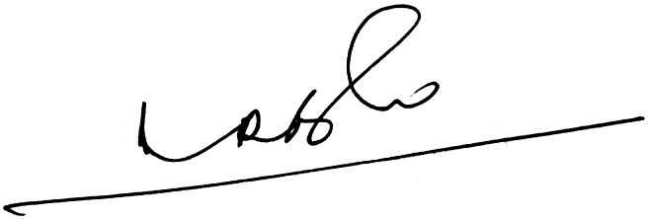 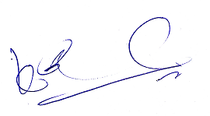 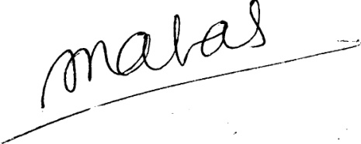

1. Ramesh Babu) (K.V. Acharya) (S.C. Jain)

Joint Conveners, CBPRO General Secretary, AIBRF