A.Ramesh Babu K.V.Acharya
Joint Convener Joint Convener,
Flat No 1103, Block 3B, J-208 Vijay Rattan Vihar,
S.M.R. Vinay Fountainhead, Sector 15, Part II,
Culvary Temple Road, Gurugram 122001
Hyderabad 500 049 E-mail: acharyavedavyasa46@gmail.com
E-mail: babu2609@gmail.com Mobile: 09868220338
Mobile: 09849381995 __________________________________________________________________________________
Circular No. 012/2018 Dated: 19.06.2018

TO
THE GENERAL SECRETARIES
Constituents of C B P R O

Dear Comrades,

C O O R D I N A T I O N
CBPRO and AIBRF Leaders met at Delhi

We wish to advise that in the wake of the judgment by the Hon’ble Supreme Court in respect of 100% DA case, we leaders of our organisation and that of AIBRF met at Delhi on 03.06.2018. The meeting was a sequel to the rounds of telephonic discussions on the implication of the adverse judgment delivered by the Hon’ble Supreme Court on 16.05.2018 in respect of 100% DA case. We discussed various alternatives including filing of review petition/ curative petition by the affected parties. The grounds for review/curative petition were also discussed in the light of a detailed analysis of the judgment undertaken by both the organisations.

The occasion was also utilised to explore the possibility of a larger unity so as to have a co-ordinated approach on important issues pertaining to Bank Pensioners and Retirees. We considered this as a welcome development. The discussions and deliberations of the said meeting were promptly intimated to the leaders of our constituents telephonically.

A joint letter dated 09.06.2018 by CBPRO and AIBRF to the Convener and the constituents of UFBU was written to demonstrate the beginning of our coordinated approach to the common issues of Bank Pensioners and Retirees. We feel that it is a good beginning and shall augur well for Bank Pensioners and Retirees movement.

We shall keep you posted of the developments from time to time.

With regards,

Yours comradely
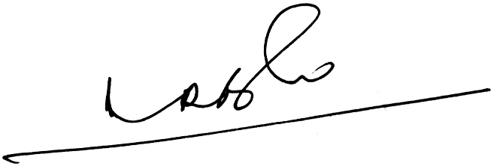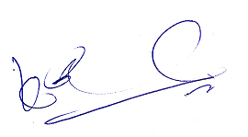
A.Ramesh Babu K.V.Acharya
Joint Conveners

