A.Ramesh Babu K.V.Acharya
Joint Convener Joint Convener,
Flat No 1103, Block 3B, J-208 Vijay Rattan Vihar,
S.M.R. Vinay Fountainhead, Sector 15, Part II,
Culvary Temple Road, Gurugram 122001
Hyderabad 500 049 E-mail: acharyavedavyasa46@gmail.com
E-mail: babu2609@gmail.com Mobile: 09868220338
Mobile: 09849381995 __________________________________________________________________________________
Dated: 21.06.2018
Shri V G Kannan,
Chief Executive,
Indian Banks’ Association,
Mumbai

Dear Sir,

Arrears of Pension Commutation with interest @ 9% on re-computation of Basic Pension
Hon’ble Supreme Court Judgment dated 13.02.2018 in case of Bank of Baroda

We refer to our letter dated 07.03.2018 requesting you to implement the order of the Hon’ble Supreme Court dated 13.02.2018 by advising the Member Banks to re-fix the Basic Pension of those Pensioners who retired between 01.04.1998 and 31.10.2002. We are happy that you had taken timely action by advising the Chief Executives of Member Banks vide your circular letter no. HR&IR/2018-19/G2/4786 dated 03.04.2018. We extend our heartfelt thanks for the same. We also thank you for advising the Member Banks to implement the judgments of Hon’ble Supreme Court regarding Pension Regulation 26 and extending another option of Pension to all the Compulsorily Retired Employees.

We understand from our constituents that most of the Member Banks have paid the arrears of pension along with interest @ 9% to the eligible Pensioners, Family Pensioners and legal heirs of the deceased Pensioners/ Family Pensioners. However we learn that the Banks have not paid the arrears of commutation and interest there on as per the entitlement arising out of re-fixation of Basic Pension. Sir, you will appreciate that the payment of commutation becomes the natural corollary of re-fixation of Basic Pension after removal of anomaly. It is a plain understanding that a correction in computation of Basic Pension would necessarily warrant a corresponding correction in the computation of commuted amount.

In view of the foregoing facts and circumstances we earnestly request you to advise the Member Banks to re-compute the amount of commutation on the basis of re-fixed Basic Pension in terms of the judgment of the Hon’ble Supreme Court and effect payment of arrears of commutation along with interest @ 9% p.a.

Thanking you

Yours faithfully,
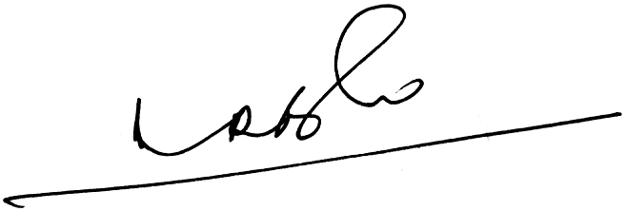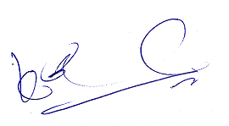
A.Ramesh Babu K.V.Acharya
Joint Conveners CBPRO

