A.Ramesh Babu K.V.Acharya
Joint Convener Joint Convener,
Flat No 1103, Block 3B, J-208 Vijay Rattan Vihar,
S.M.R. Vinay Fountainhead, Sector 15, Part II,
Culvary Temple Road, Gurugram -122001
Hyderabad 500 049 E-mail: acharyavedavyasa46@gmail.com
E-mail: babu2609@gmail.com Mobile: 09868220338
Mobile: 09849381995
__________________________________________________________________________________
Circular No: 014/2018 Dated: 17.07.2018

To

The General Secretaries of the Constituents of CBPRO

Dear Comrades,

Effective Date of Amendment to Payment of Gratuity Act 1972
Enhancement of Limit from Rs. 10 lakhs to Rs. 20 lakhs

We have once again taken up the issue of modifying the effective date of enhancement of Gratuity amount from 29.03.2018 to 01.01.2016 with the Government of India. A copy of our letter dated 16.07.2018 addressed to Shri Santosh Kumar Gangwar, Hon’ble Minister, Ministry of Labour & Employment, Government of India, Shram Shakti Bhawan, New Delhi is reproduced hereunder for the information of our Constituents and the Bank Pensioners and Retirees.

QUOTE:

We refer to our letter dated 05.04.2018 wherein we had requested your Goodself to modify the effective date of enhancement of Gratuity from Rs. 10 lakhs to Rs. 20 Lakhs to 01.01.2016 instead of 29.03.2018. In this connection we understand that in response to an on-line RTI query, the Ministry of Labour & Employment has given clarification on the effective date of the payment of Gratuity (Amendment) Act 2018 vide letter no. S-42015/02/2018-SS-II dated 28.06.2018.

The Ministry of Labour & Employment is reported to have enclosed a note FTS No. 299879/2018/LS of Ministry of Law & Justice, Department of Legal Affairs. A perusal of said note reveals the following:

- The Government had intended for parity for quantum of amount of Gratuity for the employees governed by Payment of Gratuity Act with Central Government employees.

- Central Government is also empowered to notify the parity in terms of Gratuity amount for these employees from prospective/retrospective effect.

- Hon’ble Supreme Court in case of Bharat Singh 1986 (2) SCC 614 held that it is a settled principle of interpretation that inhibition of the rule against retrospective construction may be applied with less insistence.

- Enhancement of Gratuity and its admissibility eligibility from particular date are issued relatable to social beneficial legislation and are to be construed liberally.

- According parity for quantum as well as effective date for employees governed by Payment of Gratuity Act 1972 vis a vis Central Government employees has rationale and reasonable nexus. Hence there appears to be no legal objection if said parity is allowed by Ministry of Labour & Employment.

In view of the above clarifications a kind consideration of our request to allow retrospective effect to the enhanced quantum of Gratuity w.e.f. 01.01.2016 instead of 29.03.2018 shall go a long way to uphold the principles of equity and fairness.

We therefore request your Goodself to consider our request favourably by modifying the effective date of enhancement of Gratuity amount from 29.03.2018 to 01.01.2016 and render justice.

UNQUOTE
With regards

Yours comradely
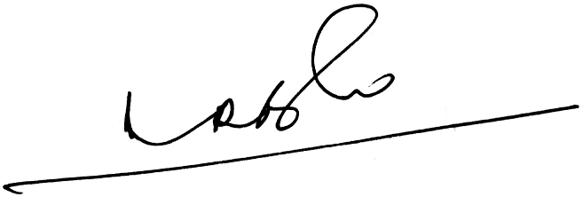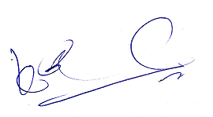
A.Ramesh Babu K.V.Acharya
Joint Conveners

