A.Ramesh Babu K.V.Acharya
Joint Convener Joint Convener,
Flat No 1103, Block 3B, J-208 Vijay Rattan Vihar,
S.M.R. Vinay Fountainhead, Sector 15, Part II,
Culvary Temple Road, Gurugram -122001
Hyderabad 500 049 E-mail: acharyavedavyasa46@gmail.com
E-mail: babu2609@gmail.com Mobile: 09868220338
Mobile: 09849381995
__________________________________________________________________________________
Dated: 16.07.2018
Shri V. G. Kannan
Chief Executive
Indian Banks’ Association
Mumbai

Dear Sir,

Renewal of Medical Insurance Policy for Bank Retirees

As you are aware the Medical Insurance Scheme was introduced by IBA in deference to the advice of the Government vide its letter dated 24th Feb 2012 and negotiations with UFBU. We wish to place it on record that it was a path breaking decision of IBA which has helped Bank Pensioners and Retirees albeit at a fairly high cost. The Bank Pensioners and Retirees have been benefited by this initiative on the part of IBA. We profusely thank you for the same.

We have been taking up rationalisation and improvements in the Medical insurance Scheme for Bank Retirees so as to fulfil the legitimate aspirations of the elders of the Banking Industry. You have been playing the role of a true catalyst in this regard.

The current medical policy effective from 01.11.2017 shall be due for renewal on 01.11.2018. We have been getting anxious enquiries from our members with regard to the premium and improvements in its coverage. We also understand that in the wake of innumerable complaints in the settlement of claims under the policy of United India Insurance Company, there are serious efforts on your part to involve other insurance companies in Public Sector in a transparent manner. We appreciate such initiatives which will also lead to competitive advantage to the Banks, Pensioners and Retirees at the time of renewal.

We wish to recall with a sense of pride that it was a laudable initiative of IBA which resulted in the medical facility being extended to the full time Directors (CMD/MD/ED/Dy. MD) of the Banks on the same lines as was available to them while in active service. In view of the consistent and steep rise in the rates of insurance premium, the Bank Pensioners and Retirees have been requesting for extension of medical facility as was done in case of full time Directors. We request you to appreciate the hardship and concern of the Retirees of the Banking Industry who have been nurturing a hope of getting free medical facility as had been extended to their superiors more than 10 years ago.

Since the due date is approaching fast, we request you to initiate timely steps to redress the grievances of the Bank Pensioners and Retirees so that the medical insurance with requested improvements can be finalized well in time through your good offices.

Thanking you

With Regards
Yours faithfully
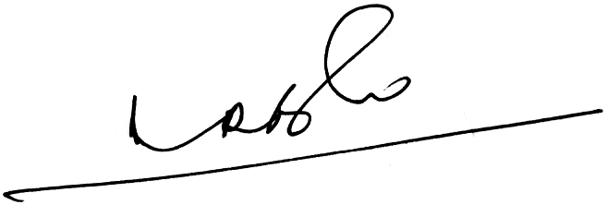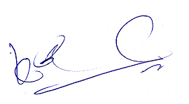
A.Ramesh Babu K.V. Acharya
Joint Conveners

