A.Ramesh Babu K.V.Acharya
Joint Convener Joint Convener,
Flat No 1103, Block 3B, J-208 Vijay Rattan Vihar,
S.M.R. Vinay Fountainhead, Sector 15, Part II,
Culvary Temple Road, Gurugram -122001
Hyderabad 500 049 E-mail: acharyavedavyasa46@gmail.com
E-mail: babu2609@gmail.com Mobile: 09868220338
Mobile: 09849381995
_____________________________________________________________________________
Dated: 17.07.2018
Shri V. G. Kannan
Chief Executive
Indian Banks’ Association
Mumbai

Dear Sir,

Anomaly in computation of Pension in State Bank of India
Hon’ble Supreme Court Judgment dated 13th Feb 2018 – Civil Appeal
No. 5525 of 2012

We wish to invite a reference to your letter no. HR & IR/2018-19/G2/4786 dated 3rd April 2018 advising the Chief Executives of Member Banks which were parties to 7th Bipartite Settlement to re-fix the Pension of those who retired after 01.04.1998, including those who retired under Special VRS 2000 on the basis of Pay Scales worked out after merging 1684 points of Consumer Price Index instead of 1616 points. The payment of arrears of pension along with 9% interest after re-fixing the pension in accordance with the judgement of Hon’ble Supreme Court in case of Bank of Baroda was required to be made within 4 months from the date of judgment (13th February 2018).

Para 8 of your letter under reference stated that as directed by Managing Committee we have taken a legal opinion to know the impact of judgement on various Banks including Nationalized Banks, Banks incorporated under Special Statutes and Private Banks which were party to the Joint Note/7th Bi-partite Settlement. These Banks were advised to pay the differential arrears in the amount of Pension which was due and payable with 9% interest within 4 months from 13.02.2018. The instructions of IBA to the member Banks were unambiguous in stating that if a Bank has implemented the provisions of Joint Note/7th Bi-partite Settlement, they should give effect and comply with the captioned judgement.

As you are aware State Bank of India is a Bank incorporated under Special Statute and has also implemented the provisions of the above mentioned Joint Note/7th Bi-partite Settlement with regard to 1616/1684 DA formulae for the purpose of calculating Pension of those who retired between 01.04.1998 and 31.10.2002. It is thus clear that State Bank of India falls within Para 8(b) of your letter dated 03.04.2018. State Bank of India is also therefore liable to pay the payment of arrears of Pension along with interest @ 9% p.a. to all the eligible beneficiaries. We understand that State Bank of India is yet to implement the 1684 DA point formulae in terms of the judgement of Hon’ble Supreme Court and your letter dated 03.04.2018. Since implementation of your instructions by State Bank of India may require some procedural ground work, it appears that the affected Pensioners in State Bank of India are yet to get their arrears. We therefore request you to take up the matter with Management of State Bank of India and advice them to remove this anomaly and implement the judgement dated 13th February 2018 of Hon’ble Supreme Court and make payment of arrears with upto date interest at the earliest.

Thanking you

With Regards
Yours faithfully

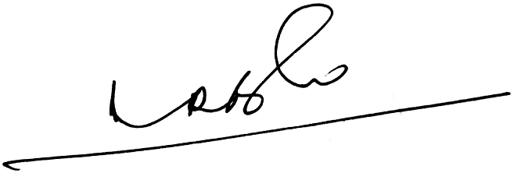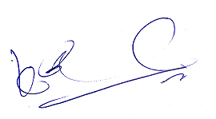
A.Ramesh Babu K.V. Acharya
Joint Conveners

