Circular 001/2018 Dated: 09.08.2018

Dear Comrades,

Immediately after the Meeting UFBU had with IBA on 8th August 2018 we contacted the Leaders of UFBU to know the developments in regard to Medical Insurance Scheme.

We are very pleased to note that UFBU LEADERSHIP had put up a strong case both in regard to the issues of Insurance Premium and further improvements in the Scheme in line with the expectations of Retiree Comrades. They have suggested continuation of the present Scheme till December 2018 so that there is enough time to sort out the issues.

Details of the deliberations of the Meeting will be available through the circular of UFBU.  CBPRO AND AIBRF will also be meeting the Leaders of UFBU shortly before their next Meeting with IBA.

We profusely thank UFBU Leadership for their efforts and hope for a good Medical Scheme for elders.

With Regards,

Yours Comradely,

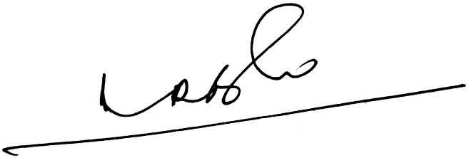 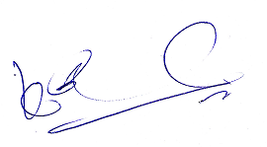 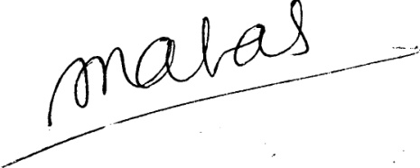

(A.Ramesh Babu) (K.V. Acharya) (S.C. Jain)

Joint Conveners, CBPRO General Secretary, AIBRF