Circular 002/2018 Dated: 20.08.2018

Dear Comrades,

Bank Retirees Issues -- Co-ordinated efforts by CBPRO AND AIBRF

Dear Comrades,

After the formation of Co-ordination between CBPRO and AIBRF we have moved forward further in pursuing all the pending issues with IBA, Department of Financial services, Ministry of Finance, Government of India and with the UFBU.

CBPRO and AIBRF Leaders met Com. C.H. Venkatachalam General Secretary AIBEA and Com. Soumya Datta , General Secretary AIBOC at Mumbai on 17th afternoon . We could not meet Com. Sanjeev Bandlish, General Secretary NCBE and Convener UFBU due to delay caused in his arrival.

We mainly discussed with them about the IBA Medical Insurance Scheme and put forward our suggestions to make the Scheme more affordable and acceptable. Our concerns were well appreciated by them and they assured all possible support from their side. We have expressed our wish to have more interactions between them and us in future too in respect of other pending issues of Bank Pensioners and Retirees.

CBPRO and AIBRF together represent almost the entire community of Bank Pensioners and Retirees and wish to move cautiously fully recognising the ground realities while pursuing the issues.

In view of the above it has also become necessary for us to clarify that CBPRO or AIBRF have NOT organised any Dharna at Jantar Mantar on 24th August 2O18. You all know that both the Organisations had earlier conducted several massive Dharnas at Jantar Mantar and at various important centres highlighting Bank Pensioners and Retirees issues.

CBPRO AND AIBRF will be meeting shortly regarding further course of actions and meanwhile wish to create and maintain conducive situation for a purposeful dialogue and discussion with all the concerned authorities and organisations so as to arrive at proper decisions in respect of our issues.

With Regards,

Yours Comradely,
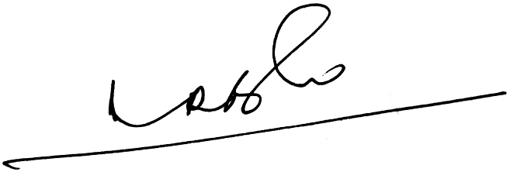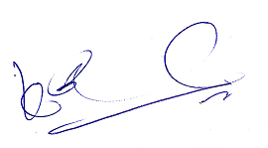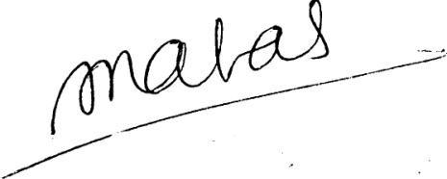
(A.Ramesh Babu) (K.V. Acharya) (S.C. Jain)
Joint Conveners, CBPRO General Secretary, AIBRF

