Dated: 30.08.2018
Com. Ajit Subhedar
The Principal Office Bearer,
United Forum of Reserve Bank Officers and Employees,
President, AIRBEA,
13, Netaji Subhas Road,
Kolkata 700001

Dear Com. Subhedar,

Sub: Your proposed country-wide Protest Mass Casual leave on 4th & 5th September, 2018 in respect of Issues of Pensioners & Retirees of RBI.

We are immensely pleased to come across your circular and Press hand out dated 28.8.18 declaring your protest action by going on Mass Leave on 4th & 5th September, 2018 in respect of important pending issues of Pensioners of RBI. The issues raised by you are mainly:

- Pension Updation

- One more option to switch over from CPF to Pension

- Additional Provident Fund scheme for those recruited after 2012(coming under New Pension Scheme).

When Defined Benefit Pension Scheme was introduced in RBI, Public & Private Sector Banks and in LIC it was clearly stated that the Pension Scheme would be on the lines of Pension Scheme available to Government Employees and to that extent either the Regulations were framed or Resolutions by the Governing Councils of the respective institutions were passed. Accordingly in RBI also Pension was brought in alignment with pay scales of 1997-2002. It is unfortunate that at the instance of Government of India the decision of the Governing Council of RBI was negatived without any rhyme or reason jeopardizing the competency of the Governing Council of RBI and arbitrarily the Updation of Pension was rescinded even by ignoring the Hon'ble Mumbai High Court decision. It is strange that such a discriminatory treatment should be given to RBI Pensioners & Retirees when Retired Government employees are getting the periodical Updation with every Pay Commission Recommendation. It is all the more intriguing to note that even when strong Pension Corpus is available to meet any financial implications, be it Implementation of Updation of Pension or agreeing to give one more Option for Pension to CPF Op-tees the same are unjustifiably denied.

Unfortunately the same is the fate so far as the Bank Retirees or LIC Retirees are concerned. The rightful legal entitlements of the Retirees should not be allowed to be denied and so you have rightly taken up the cause of the Retirees by launching Action Programmes including the protest Mass Casual Leave. We on behalf of Bank Pensioners & Retirees wholesomely appreciate your stand and extend our whole-hearted fraternal Support to all your Action Programmes including our participation in your demonstrative actions in different centers.

We wish all success to your endeavors in this regard and also wish to co-ordinate with all Organisations who espouse the cause of Pensioners & Retirees.

We once again convey our heartfelt thanks to you all for taking up the cause of the Pensioners & Retirees and we are certain that you will succeed in ensuring justice.

With Warm Greetings,

Yours Comradely,
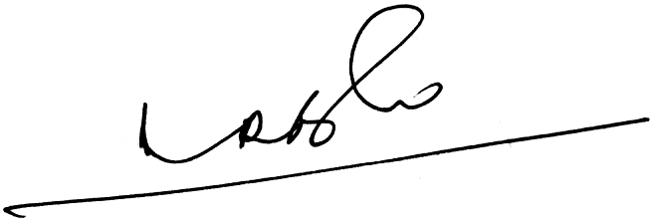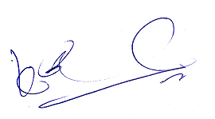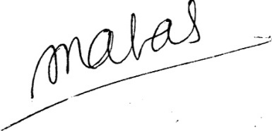
- Ramesh Babu) (K.V. Acharya) (S.C. Jain)
Joint Conveners, CBPRO General Secretary, AIBRF
P.S. We request all the Retirees’ Organisations to extend the full support and join the Demonstrations organised by them.

