Dated: 10.08.2018

The Chairman,
Goods and Service Tax Council,
5th Floor, Tower II,
Jeevan Bharati Building,
Janpath,
New Delhi 110001

Respected Sir,

Request to exempt Medical Insurance Premium for Senior Citizens from GST

We wish to introduce both the above organisations as the Representative Bodies of all the Bank Pensioners and Retirees numbering about six laks including those of State Bank of India. The Bank Pensioners and Retires were extended the facility of Group Medical insurance by Indian Banks’ Association through United India Insurance Company in the year 2015. The Medical Insurance Policy was renewed w.e.f 01.11.2016 when GST was not introduced. However the next renewal w.e.f. 01.11.2017 was done subsequent to the introduction of GST from 01.07.2017. Accordingly the Medical Insurance Premium for the period 01.112017 to 31.10.2018 was subjected to GST @ 18%.

We have been appreciative of the initiative of the Government of India for having envisaged a National Level Health Care Scheme as announced in the Union Budget for the current year by the Hon’ble Finance Minister. We also take this opportunity to congratulate the Government for the proposed launch of the scheme on 15th August, 2018. With such emphasis by the Government on Health Care of the people of the country, it is our fair and reasonable expectation that the Group medical Insurance Scheme for the Senior citizens of Banking Industry is made attractive and affordable by exempting the amount of premium from the applicability of 18% GST.

We also wish to mention here that the amount of GST for a Medical Insurance cover of Rs. 9 Lakhs comes to Rs. 19,848 as the insurance premium for ensuing renewal w.e.f from 01.11.2018 have been steeply increased by United India Insurance Company. We would also like to submit that our members draw Pension even as low as Rs. 4,000/- per month in case of Family Pensioners which would render their affordability to pay a premium of Rs. 95,548/- (including GST) completely out of bounds. The poor Senior Citizens shall thus be driven out of the IBA’s Medical Insurance Scheme which was introduced in the year 2015 after protracted discussions and negotiations on the advice of Department of Finance Services, Ministry of Finance vide their letter No. F14/7/92-IR(Vol. II) dated 24.02.2012 addressed to IBA.

A kind consideration to our request to exempt Medical Insurance Scheme premium in case of Senior Citizens from GST shall partially mitigate the hardship and financial burden imposed on our members. It will also be a very special gesture of the Government of India towards better Health Care of the Senior Citizens in furtherance of the avowed agenda of the Government.

We also request you to kindly exempt GST on Hospitalisation Bill of Senior Citizens as otherwise it eats away a good portion of the Medical Insurance Amount in paying GST alone.

In view of the foregoing submissions, we earnestly request your Good-self to consider our request sympathetically and exempt the Medical Insurance Premium of Senior Citizens from applicability of GST and oblige the larger constituency.

With regards

Yours faithfully

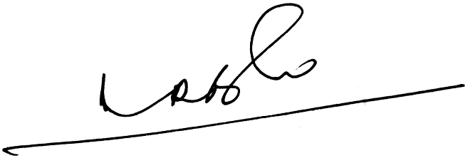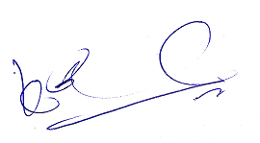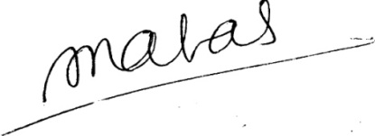

(A.Ramesh Babu) (K.V. Acharya) (S.C. Jain)
Joint Conveners, CBPRO General Secretary, AIBRF

