Dated: 10.08.2018
Shri Santosh Kumar Gangwar
Hon’ble Minister
Ministry of Labour & Employment
Government of India
Shram Shakti Bhawan
New Delhi

Hon’ble Sir,

Effective Date of Amendment to Payment of Gratuity Act 1972
Enhancement of Limit from Rs. 10 lakhs to Rs. 20 lakhs

We refer to our letters dated 05.04.2018 and 16.07.2018 wherein we had requested your Good-self to modify the effective date of enhancement of Gratuity from Rs. 10 lakhs to Rs. 20 Lakhs to 01.01.2016 instead of 29.03.2018. As submitted in our letter dated 16.07.2018, the Ministry of Labour & Employment has given clarification on the effective date of the payment of Gratuity (Amendment) Act 2018 vide letter no. S-42015/02/2018-SS-II dated 28.06.2018 in response to an on-line RTI Query raised by Shri R. Padmanabhan of Bangalore. While replying to RTI Query, the Ministry of Labour & Employment is reported to have enclosed a note FTS No. 299879/2018/LS of Ministry of Law & Justice, Department of Legal Affairs.

Ministry of Law and Justice has opined that the enhancement of Gratuity and its adminisibilty, eligibility from particular date are issues relatable to social beneficial legislation and are to be construed liberally. According to parity (for Quantum and as well as date of eligibility) for the employees governed by the Payment of Gratuity Act 1972 vis a vis Central Government Employees has rationale and reasonable nexus and hence the Ministry of law and Justice opined that there was no legal objection if said parity is favourably considered by the Ministry of Labour and Employment.

A perusal of the note dated 23.03.2018 (FTS No. 299879/2018/LS) of Ministry of Law and Justice, Department of Legal Affairs reveals the following:

- The Government had intended for parity for quantum of amount of Gratuity for the employees governed by Payment of Gratuity Act with Central Government employees.

- Central Government is also empowered to notify the parity in terms of Gratuity amount for these employees both from prospective and or retrospective effect.

- Hon’ble Supreme Court in case of Bharat Singh 1986 (2) SCC 614 held that it is a settled principle of interpretation that inhibition of the rule against retrospective construction may be applied with less insistence.

- Enhancement of Gratuity and its admissibility eligibility from particular date are issues relatable to social beneficial legislation and are to be construed liberally.

- Accordingly parity for quantum as well as effective date for employees governed by Payment of Gratuity Act 1972 vis a vis Central Government employees have rationale and reasonable nexus. Hence there appears to be no legal objection if said parity is allowed by Ministry of Labour & Employment.

Sir, you will appreciate that the enhancement of Gratuity from Rs. 10 Lakhs to Rs. 20 Lakhs for Central Government Employees was recommended by the Central Pay Commission, justifying such increase in view of the fall in purchasing power due to inflationary trend. It is submitted that inflation hurts all citizens in equal measure as it does the Central Government Employees. This lends credence and justification to our request for restoration of parity in the effective date also.

In view of the above clarifications a kind consideration of our request to allow retrospective effect to the enhanced quantum of Gratuity w.e.f. 01.01.2016 instead of 29.03.2018 shall go a long way to uphold the principles of equity and fairness. It will also be in conformity with principle laid down by Hon’ble Supreme Court in case of Bhagat Singh 1986 (2) SCC 06.01.2004

We therefore request your Good-self to consider our request favourably by modifying the effective date of enhancement of Gratuity amount from 01.01.2016 instead of 29.03.2018 and render justice.

With regards

Yours faithfully
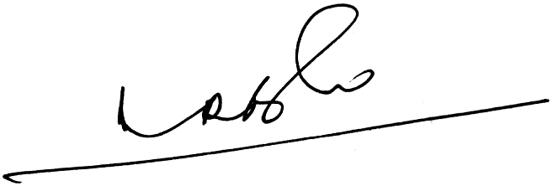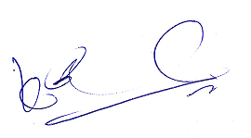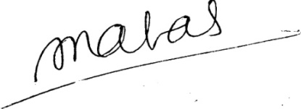

(A.Ramesh Babu) (K.V. Acharya) (S.C. Jain)
Joint Conveners, CBPRO General Secretary, AIBRF

