Circular 004/2018 Dated: 11.09.2018

Dear Comrades,

Proceedings of CBPRO & AIBRF Meeting at Delhi on 08.09.2018

The Leaders of CBPRO and AIBRF met at Delhi on 8th September, 2O18 to discuss further course of actions in regard to all Pending issues of Bank Pensioners and Retirees.

At the outset Com. K .V. Acharya , Joint Convener CBPRO welcomed the Leaders of CBPRO and AIBRF to the Meeting pointing out that the Coordination has been working well right from inception evoking hopes and enthusiasm among the Bank Pensioners and Retirees. He also stated that the leadership of both the Organisations have decided to work in unison and speak in one voice to achieve the goal for which the Co-ordination was formed.

After that the Leaders assembled, discussed the issues at length giving their valuable views and suggestions underlining the spirit of Coordination vis-a-vis Bank Pensioners and Retirees expectations and aspirations.

Com.SC Jain General Secretary AIBRF initiated the discussion. Shri Jain also expressed the view that after the formation of the Co-ordination quite a few communications, joint memorandums and circulars were issued by the CBPRO & AIBRF jointly highlighting the issues of the Retirees. He also expressed confidence that the coordination will continue to work espousing the cause of the Retirees.

This was followed by suggestions & observations from Com PK Pathak, Federation of SBI Pensioners Associations, Com .Suprita Sarkar of AIBPARC, Com. S M Deshpande of AIBRF, Com Subhash Ahuja of RBONC and Com J D Sharma of AIBPARC. The same were echoed by Com. RC Goel of FORBE.

The issues discussed and decisions taken in the Meeting are as under.-

1. IBA Medical Insurance Scheme : Immediately going by the urgency of the issue concerning highly unreasonable and exorbitant premium proposed by the Insurance company all out effort is needed to get a thorough Review of the same and suggestions contained in our letter to UFBU should be accepted by IBA, Bank Managements and Insurance Company. It was decided that we should wait and watch for the outcome of the Meeting between IBA Committee and UIIC slated for 10th September 2O18. Everybody felt that Union Bank of India should not have rushed through their circular regarding the Premium to be paid by the Retirees without even waiting for the final outcome of the Meeting demonstrating Union Bank's insensitivity on such an emotive issue of Medical Care of their elders. It is decided that while effort should be made to retain IBA Medical Insurance Scheme with reasonable and affordable premium, the IBA also should honor the Medical Insurance Scheme which was part of the last Bipartite Settlement. The IBA also should not give an impression that they are planning to get the IBA Medical Insurance Scheme become defunct by allowing the Insurance Company to hike the premium exorbitantly and forcing the Bank Pensioners and Retirees to opt out of the scheme negating the provision of the last Bipartite Settlement in respect of the Medical Insurance. This is also against the spirit of the communication sent by the Dept of Financial Services, Government of India.

Charging a premium of Rs 56000/- for a domiciliary treatment with the reimbursement entitlement of Rs 40000/- only coupled with the reduction of Base Policy value of Rs 4.00 lacs to Rs 3.60 lacs defies all logic and arithmetical intelligence and rationality. This is also in contravention of IRDA guidelines. However in the meeting it is decided that we should wait for outcome of the meeting between IBA and UIIC scheduled for 10th Sept, 2018. A suitable response by the coordination will be worked out once the final position emerges on the Medical Insurance Scheme.

Now it is understood that in the meeting that took place on the 10th Sept, 2018 suggestions jointly given by CBPRO & AIBRF were also discussed. Further meeting on Medical Insurance will take place on 14th Sept, 2018 and we are hopeful that UFBU will further take up the issue of premium and Medical Insurance Scheme.

2. It is also decided that Family Pension being another very emotive issue a full scale thrust should be given to clinch the same as early as possible by giving high level publicity at every forum and approach every authority including political parties.

3. On Updation of Pension, DA neutralization, Pension to Resignees, Effective Date in respect of Implementation of Enhancement of Gratuity amount , Reckoning of Special Allowance for Terminal Benefits retrospectively from November 2012(10th Bipartite Settlement), and Uniform Implementation of IBA communications in respect of benefits and other pending matters should be pursued still more vigorously, if necessary even by launching agitations simultaneously supporting legal battles which are in the final stages of disposal.

It is also decided that the Joint Conveners of CBPRO Com A Ramesh Babu and Com K V Acharya and Com. SC Jain General Secretary AIBRF will together take decisions in respect of any further course of actions as and when required necessary.

It is also decided that periodical Meetings between UFBU and Our Coordination will be necessary where all issues concerning Pensioners and Retirees are discussed fully, information regarding issues shared mutually supporting our CAUSE. A suitable joint letter will be sent to UFBU leaders in this regard.

The Meeting ended on a note of confidence with Reassertion of UNITY and a Determined Approach to achieve the hitherto Denied Rights of Bank Pensioners and Retirees and get JUSTICE.

Com Suresh Sharma of AIBRF proposed the vote of thanks.

With Regards,

Yours Comradely,
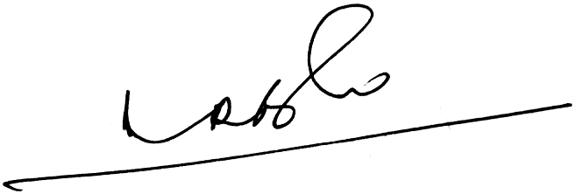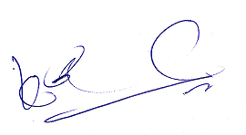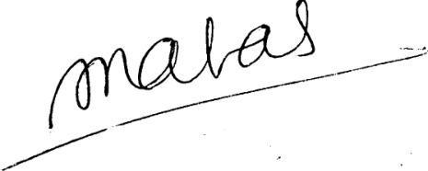
(A.Ramesh Babu) (K.V. Acharya) (S.C. Jain)
Joint Conveners, CBPRO General Secretary, AIBRF

