Dated: 20.09.2018
Shri Sanjeev K Bandlish
Convenor, UFBU
General Secretary, NCBE
Chandigarh 160017

Dear Com. Bandlish,

IBA Medical Insurance Scheme for Bank Retirees

We refer to your letter No UFBU/2018/12 dated 17.09.2018 addressed to IBA regarding Medical Insurance Scheme encompassing the scheme for Retirees too. While we appreciate your efforts to resolve the issue of retirees we have a few suggestions in further modification of the suggestions you have made to the IBA.

- While cost has to be reduced by going for competitive bidding the banks shall also come forward to bear a part of the premium as a principle so that gradually the banks bear the premium fully in course of time. To start with, the banks may bear 75% if not fully the insurance premium of family pensioners/spouses of deceased retirees and 50% the premium of retirees. This matter of subsidizing the medical insurance premium shall not be left to individual banks.
- While it is welcome to have five flexible slabs of Super-Top Up policy without reference to cadre the same flexibility and also an additional slab of Rs.4 lac for Basic Policy without reference to the cadre is required. At present the maximum cover with Basic plus Super Top Up is Rs. 9 lac and the same maximum should be maintained by extending a choice to the retirees of existing slab of Rs.4 lac.or one more slab of Rs.6 lac in Super Top Up.
- The medical insurance cover has to be combined for serving employees and retirees to have uniform insurance premium as it was when this scheme was introduced.
- We do also appreciate the suggestion of lower premium for single person cover.
- Retirees are anxious as there is not much time to make arrangements for the premium payment.

We trust and hope that modifications as above will be ensured by the UFBU, and IBA will be prevailed upon to bring much needed relief to the retirees in the matter of medical insurance.

Thanks and regards

Yours Comradely
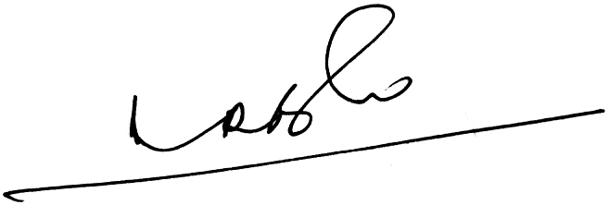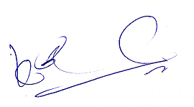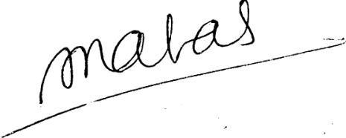

- Ramesh Babu) (K.V. Acharya) (S.C. Jain)
Joint Conveners, CBPRO General Secretary, AIBRF

