Dated 13.09.2018
Com. Sanjeev K Bandlish
Convener, UFBU
General Secretary, NCBE
Chandigarh

Dear Com. Bandlish

Pending Issues of Retirees

We are happy to learn that UFBU has taken our suggestions communicated to you vide our letter dated 23.08.2018 on Medical Insurance Scheme for Bank Retirees in right earnest and have advanced the same to IBA in your last meeting. We are confident that initiative taken by UFBU in this regard shall bear fruits. We are also looking with a sense of optimism that the meeting of HR GM’s constituted by IBA with the Senior Officials of UIIC at Chennai shall lead to significant reduction in the amount of Insurance Premium so as to make it reasonable and affordable. However it would be our natural expectation that the premium amount is borne by respective Banks for the following reasons:

- Free Medical Insurance facility is provided to the Serving Employees and Officers

- Unlimited Medical reimbursement facility is provided to the Retired EDs/MDs/CMDs of the Banks for self and spouse

- Banks’ Retired Employees and Officers alone have been denied of Free Medical Insurance/Reimbursement facility for self and spouse as extended to Serving Employees and Retired Eds, Mds and CMDs despite the fact that the communication dated 24.02.2012 from DFS did not direct the Banks or IBA to resort to any such discrimination between Serving and Retired Employees with regard to payment of premium while evolving NEW MEDICAL INSURANCE SCHEME.

You will appreciate that the Bank Retirees have made significant contributions for the growth of Banking System in India and hence deserved a fair treatment with regard to their post-retiral benefits including good health care in the evening of their life. We have therefore been persistently requesting the leaders of UFBU to pursue the pending issues of Bank Pensioners and Retirees with IBA/Government and help resolve the same in an amicable manner. We are confident that the combined efforts shall lead to success and provide succour.

As you are aware CBPRO & AIBRF have forged a broader coordination to take up the pending issues of Bank Pensioners and Retirees. In pursuance thereof, we had a joint meeting of the leaders of the constituents of CBPRO and the leaders of AIBRF at Delhi on 08.09.2018. The following issues were discussed in the meeting:

- Medical Insurance Scheme to be made affordable
- 100% DA case
- Updation of Pension
- Improvement in Family Pension as available in Government and RBI
- Reckoning of Special Allowance for the purpose of Terminal Benefits viz Pension and Gratuity from the original date of its introduction through 10th Bipartite Settlement/Joint Note
- Pension option to Resignees who had put in minimum qualifying service.

After deliberations on the issues, the leaders expressed their view that the Joint Coordination of CBPRO & AIBRF should have periodical meetings with UFBU and there should be mutual sharing of information between UFBU and the Joint Coordination of Retirees in respect of the pending issues so as to enhance the efficacy of the efforts for resolving the issues. We therefore request you to facilitate such meetings. The leaders of our Joint Coordination are prepared to participate in such meetings at the venue convenient to UFBU.

We understand that the next meeting between UFBU and IBA is scheduled for 14th September 2018 at 3 pm and the issue of Medical Insurance Premium for Retirees policy shall be a priority item for discussion. Since the due date for renewal of the Policy is fast approaching we once again request you to convince IBA to ensure reduction in the premium to make it affordable by advising the Banks to absorb the same and or subsidise adequately.

We look forward for a favourable outcome.

With regards

Yours Comradely,
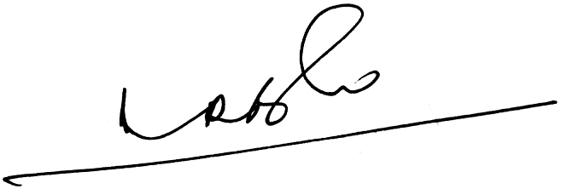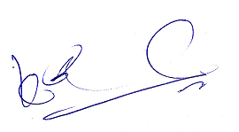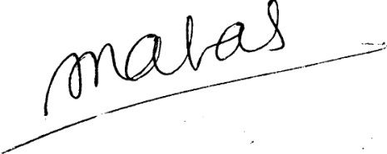
(A.Ramesh Babu) (K.V. Acharya) (S.C. Jain)
Joint Conveners, CBPRO General Secretary, AIBRF

