Circular 006/2018 Dated: 10.10.2018

Dear Comrades,

Renewal of Medical Insurance Scheme for Retirees
for the year 2018-19

The Group Insurance Policy for the Bank Retirees under IBA’s Scheme is due for renewal w.e.f. 01.11.2018. The uncertainty in respect of high rate of premium due to steep increase over the premium of previous year has been a significant cause of concern and anxiety not only to the Retirees but also to their organisations. We have been constantly following up the matter with UFBU/IBA/DFS, Government of India impressing upon them the need for reduction in the premium so as to make it reasonable and affordable. The combined efforts of CBPRO and AIBRF have yielded some favourable result as the increase in premium on Basic Insurance amount has been restricted to 75% instead of 110% proposed earlier. Similarly the increase in premium with domiciliary facility is restricted to 123% instead of 144% proposed earlier.

Our suggestion to introduce a lower slab of Rs. 3 Lakh for officers and Rs. 2 Lakh for award staff under the Basic insurance Policy has been accepted and may be favourable to single persons/Family Pensioners. However the Insurance Company has partially robed the benefit of reduced premium by increasing the premium of Super Top-up Policy for those who opt for reduced Basic Cover of Rs. 3 Lakh and Rs. 2 Lakh in case of officers and award staff respectively.

We are happy with the reduction in the quantum of premium and other modifications in the scheme suggested by us. We wish that the other suggestions given by us were also accepted but constraint of time leaves us with little choice but to go with the revision in the scheme as communicated by IBA wide its Circular No. CIR/HR&IR/VRK/2018-19/6037 dated 09.10.2018 sent to CEO’s of all the Member Banks. We still reiterate our demand for banks to bear the premium on behalf of pensioners and Retirees as in the case of Serving Employees. We have been requesting IBA and the Government to direct the Banks to remove the discrimination with regard to payment of premium of Retirees vis a vis Serving Employees. Meanwhile the amount of premium in case of Retirees may be substantially subsidised by the Banks.

We furnish below the amount of Insurance Premium for different categories for ready reference of the members:

Category | Sum insured (Rs.) | Premium inclusive GST (Rs.)
Award Staff without Domiciliary | 2,00,000 | 20320
Award Staff without Domiciliary | 3,00,000 | 21595
Award Staff with Domiciliary | 2,00,000 | 57647
Award Staff with Domiciliary | 3,00,000 | 61784
Officers without Domiciliary | 3,00,000 | 27745
Officers without Domiciliary | 4,00,000 | 28792
Officers with Domiciliary | 3,00,000 | 78236
Officers with Domiciliary | 4,00,000 | 82373

Super Top-up

Award Staff :
Basic Policy Rs.2 Lakh + Super top-up Rs.4 Lakh premium is Rs. 6986/- including GST
Basic Policy Rs.3 Lakh + Super top-up Rs.4 Lakh premium is Rs. 4657/- including GST

Officers:
Basic Policy Rs.3 Lakh + Super top-up Rs.5 Lakh premium is Rs. 7574/- including GST
Basic Policy Rs.4 Lakh + Super top-up Rs.5 Lakh premium is Rs. 5049/- including GST

Per day room rent Rs. 4000/- for all

We advise the members in readiness to exercise option on issuance of circular by their respective Banks.

We take this opportunity to thank the Convener and other leaders of UFBU who have been quite receptive and sympathetic to our demands for rationalisaton of IBA’s Medical Insurance Scheme for Retirees including reduction in premium.

With Regards,

Yours Comradely,
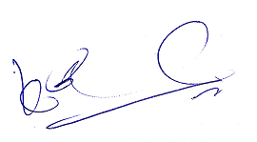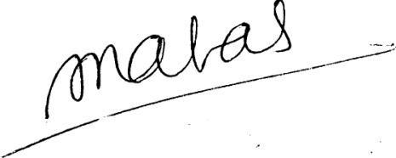
(A.Ramesh Babu) (K.V. Acharya) (S.C. Jain)
Joint Conveners, CBPRO General Secretary, AIBRF

