Dated: 16.10.2018

Shri V G Kannan

Chief Executive Officer,

Indian Banks’ Association,

Mumbai

Dear Sir,

**Renewal of Medical Insurance Scheme for Retirees 2018-2019**

We invite reference to your Circular No. CIR/HR&IR/BRK/2018-19/6037 dated 09.10.2018 and Circular No. CIR/HR&IR/BRK/2018-19/6084 dated 15.10.2018 advising the Member Banks the rates of premium and the amount insured. In this connection we wish to bring out the following to your notice and kind consideration:

1. Introduction of new slab of Rs. 3 Lakhs for Officers and Rs. 2 Lakhs for Award staff was a welcome feature. However stipulating a premium of Rs. 23,513/-(Without Domiciliary) for a cover of Rs. 3 Lakhs for officers as against a premium of Rs. 18,301/- for a cover of Rs. 3 lakhs for award staff defied logic and reasoning. We are of the considered view that IRDAI guidelines do not provide for discriminatory pricing for the retirees under the Group Insurance Policy. It is painful that instead of rationalising the amount of premium to make it uniform irrespective of cadre of the employees i.e. officers or award staff, by effectively taking up with UIIC, IBA preferred to unilaterally abolish the facility of new slab thereby depriving the members an opportunity to opt for lower amount of insurance cover according to their affordability and risk perception. In as much as the retirees are the beneficiaries and also paying the premium, we as the Coordination of Retirees’ Organisations representing 100% of the membership, it was the normal expectation that IBA would call us for a discussion before taking a final call in the matter. We once again reiterate our demand for participative and collective decision making in the matters pertaining to the Bank Pensioners and Retirees.
2. We had also suggested introduction of new slabs for Basic policy to provide cover of Rs. 1 Lakh, Rs. 2 Lakhs and Rs. 3 lakhs so as to help the Family Pensioners or single persons covered under policy to derive the benefit of lower amount of premium more so when the rate of Family Pension is as low as Rs. 4000/- per month in many of the cases. We request you to reconsider our suggestion on purely sympathetic grounds.
3. We have also been requesting for the premium to be borne by the Banks as the letter dated 24.02.2012 from Government of India advising to evolve Medical Insurance Policy both for Serving and Retired employees did not contain any stipulation to discriminate the Retired employees with regard to payment of premium vis a vis the serving employees or even the retired

CMDs/MDs/CEOs/EDs etc. Under such circumstances singling out the Retired Award Staff and Officers alone for discriminatory treatment is beyond any reasonable comprehension. We therefore once again request you to reconsider our demand and advise the Member Banks to bear the premium for the Retirees Medical Insurance. You will appreciate that steep increase in the premium every successive year has been a cause of serious concern as it has been resulting in a corresponding decline in the number of beneficiaries covered under the scheme. We submit that until arrangements are made for Banks to bear the entire amount of premium, IBA should direct the Member Banks to subsidise at least 50% of the premium amount.

1. We also reiterate our demand for a unified and integrated Medical Insurance Cover both for Serving Employees and Retirees so as to bring down the claim paid ratio and eventually the premium amount per member. We sincerely request you to explore the possibility of a single Group Medical Insurance Policy for Serving Employees and Retirees of the Banks.

We shall be happy if our suggestions are considered favourably to bring about parity and justification with regard to treatment of insurance premium for Retirees vis a vis Serving Employees. Kindly do the needful and oblige,

Thanking you,

Yours faithfully,

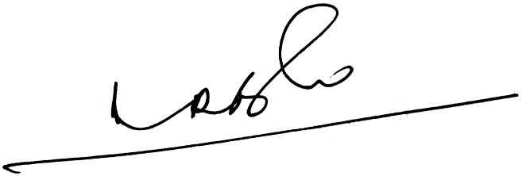 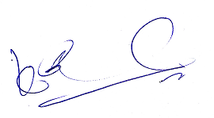 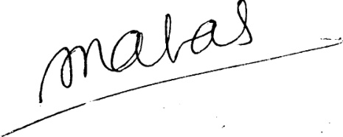

(A.Ramesh Babu) (K.V. Acharya) (S.C. Jain)

Joint Conveners, CBPRO General Secretary, AIBRF