**Circular No.:  010/2018**.             Dated: 24.12.2018

**To**

**All the Constituents, Affiliates and Members**

Dear Comrades,

**JOINT ACTION PROGRAMME -**

**COUNTRY-WIDE DHARNA AND DEMONSTRATIONS**

We wish to invite a reference to our Circular No.  09/2018 dated 05.12.2018 on the captioned subject.  In this connection, we express our happiness and satisfaction that our Dharna and Demonstration Programmes at different centres have already been conducted very successfully. We have received reports from our units at places like Bangalore,  Trivandrum,  Ernakulam, Kolkata etc about their having conducted massive Dharna and Demonstration at their respective centres which were attended by several thousands of the Bank Pensioners and Retirees.  The large and massive participation by the members exhibits the enthusiasm of the members to fight for the pending issues and other legitimate demands of the Bank Pensioners and Retirees.

It is heartening to note that our constituents and affiliates have been able to forge unity and bond with each other for the success of our Joint Action Programme. We are getting information from all the designated centres about the preparation being made by them to hold Dharna and Demonstration at the respective centres. We advise our comrades at the remaining centres to arrange to hold Dharna and Demonstration at their respective centres within the given time frame and send us reports.

It is worth mentioning here that our Kerala State Unit has decided to organise and hold such Dharna at all the District Head Quarters.  We extend our special greetings and Best wishes for the efforts of our Kerala Comrades and hope that others State Units shall also emulate the good work being done by the comrades of Kerala State.

We have also received reports from our Hyderabad Unit and Chennai State Unit about their preparations for a massive Dharna on 05.01.2019 and 08.01.2019 respectively.  We wish them all success for the smooth conduct of the Dharna and Demonstration.

We once again advise our Comrades to ensure submission of the Joint Memorandum to the concerned authority stationed at the centre of our Dharna.

**We are pleased to advise our Comrades that it has been decided to hold a massive Dharna at Jantar Mantar New Delhi on 07.01.2019** followed by a March to Parliament and submission of the Joint Memorandum on our pending issues to the Hon'ble Prime Minister of India.  Our state Unit at Mumbai is also busy chalking out programmes for a massive Dharna and Demonstration in the first/second week of January 2019 and submission of Joint Memorandum to IBA Chief and MD/CEOs of the banks headquartered in Mumbai.

We request our state units and comrades to leave no stone unturned to make the joint action programmes memorable and grand success. Please also try to get maximum media attention and publicity not only to our programme but also to the reasonableness and legitimacy of all the pending issues of Bank Pensioners and Retirees.

With best wishes and greetings,

Yours Comradely,

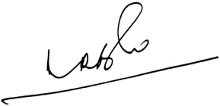 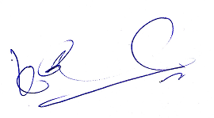 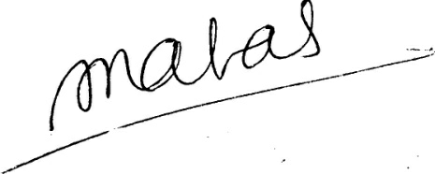

**(A.Ramesh Babu) (K.V. Acharya) (S.C. Jain)**

**Joint Conveners, CBPRO General Secretary, AIBRF**