Dated: 29.11.2018
Shri Sanjeev Kumar Bandlish,
Convenor, UFBU

Dear Comrade Bandlish,

Denial of Additional Stagnation increment to those who retired between 1.11.2012 & 30.4.2015

The 10th BPS/Salary Revision Joint note was signed between IBA and the constituents of UFBU on 25.05.2015. It provided for stagnation increment for every 3 completed years of service after reaching the maximum of Pay Scale with a further stipulation that the last of the stagnation increment will be granted to those who have completed 2 yrs or more after getting the previous stagnation increment. It was also stipulated that the increments which fell due after completion of 2 yrs from the date of grant of previous stagnation increment will be given with effect from 01.05.2015.

It is pertinent to point out that the effective date of the 10th Bipartite settlement/ Joint Note was 01.11.2012 and in all fairness those officers who were due for additional stagnation increment between 01.11.2012 and 30.04.2015 after having completed 2 yrs from the date of previous stagnation increment should have been allowed to earn their last stagnation increment from the date on which it fell due anytime on or after 01.11.2012. However this benefit of earning stagnation increment on completion of 2 yrs from the date of previous stagnation increment was denied to the Officers by stipulating that 4th / 5th stagnation increment will be given w.e.f: 01.05.2015 in MMG scale II and MMG scale III respectively. There were similar stipulations for clerical employees also.

Denial of Additional Stagnation Increment on completion of 2 yrs from the date of previous stagnation increment and extending the date of additional stagnation increment to 01.05.2015 in an arbitrary manner has resulted in a financial loss to the Officers in the following manner:

- Loss of Arrears and reduction in the 10 months average pay for computation of Basic Pension to those who retired between 01.05.2015 and 31.01.2016.
- Complete loss of Arrears on account of additional stagnation increment due between 01.11.2012 and 30.04.2015 and denial of benefit for computation of Basic Pension to those who retired between November, 2012 and April, 2015.

We understand that State Bank of India took up the matter with IBA seeking consent on the basis of opinion of their law department so as to extend the benefit of additional stagnation increment from a notional date or 01.11.2012 whichever is earlier with a provision to allow monetary benefit from 01.11.2012 i.e. the date of implementation of 10th BPS/Joint Note. Accordingly SBI has corrected the date of additional stagnation increment in respect of non-subordinate employees by extending monetary benefit from 01.11.2012. We also understand that SBI Corporate Centre, Mumbai has issued a circular on 18.07.2018 in this regard under the signature of CGM (HR).

Under these circumstances we request you to take up the matter with IBA for issuing appropriate guide lines to all the member banks who were parties to the 10th Bipartite settlement/ Joint Note date 25.05.2015 and advise them to extend the benefit to similarly placed employees/officers.

With regards,

Yours Comradely,
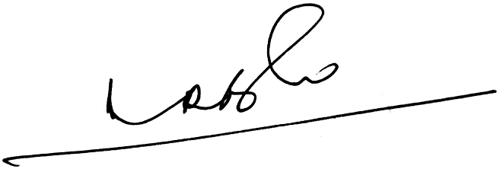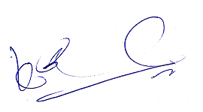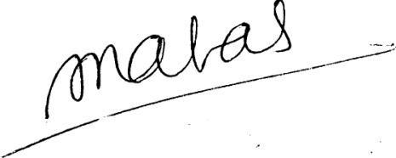
(A.Ramesh Babu) (K.V. Acharya) (S.C. Jain)
Joint Conveners, CBPRO General Secretary, AIBRF

We are making a similar request to IBA.

