Dated: 24.12.2018

To

Com. Sanjeev K Bandlish,

Convener, UFBU

Dear Comrade Bandlish

**INVITATION TO ADDRESS OUR DHARNA AT JANTAR MANTAR, DELHI**

**ON 07.01 2019**

we wish to advise you that we are in the midst of our  Agitation Programme of holding country-wide Dharna at various important centres including all State Capitals between 01.12.2018 and 15.01.2019 and submission of a Joint Memorandum highlighting the following pending issues of Bank Pensioners and Retirees:

1. Updation/Revision of Pension.
2. Revision of Family Pension.
3. 100 %DA neutralisation to pre-Nov. 2002 Retirees.
4. Improvements in SBI Pension Scheme.
5. Removal of anomalies in Fixation of Pension in SBI including Commutation at par with Industry and reckoning Probationary period of service for Calculation of Pension.
6. Defined Benefit Pension Scheme to those who   are recruited after April 2010.
7. Pension to Resignees with pensionable service.
8. Reimbursement of Medical Insurance Premium to Retirees.
9. Reckoning of Special Allowance for Gratuity and Pension.
10. Grant of Negotiating Rights with IBA.
11. Implementing all judgments of Hon’ble Supreme Court for Pensioners and.  Retirees.
12. Enhancing gratuity to RS. 20 lacs w.e.f. 01.01.2016.

We have decided to hold a Massive Dharna at Jantar Mantar, Delhi on 07.01.2019 followed by a March to Parliament in the afternoon on the same day and submit a Joint Memorandum to the Hon'ble Prime Minister seeking his intervention to resolve all our pending issues.

We extend our cordial invitation to you and request you to spare some time from your busy schedule and address our Dharna any time between 11.00 AM and 1.30 PM according to your convenience.  Such a special gesture on your part will go a long way in enthusing the Pensioners and Retirees who will gather at Jantar Mantar on 07.01.2019, despite adverse weather conditions and their growing age.

We also take this opportunity to thank you sincerely for continuing to take up the pending issues of Bank Pensioners and Retirees.

Looking forward to welcoming you to our Dharna on 07.01.2019 at Jantar Mantar Delhi

With regards and New Year Greetings,

Yours Comradely,

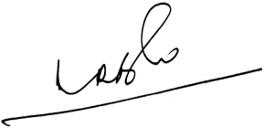 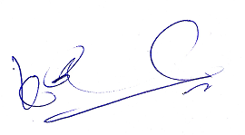 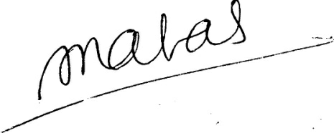

**(A.Ramesh Babu) (K.V. Acharya) (S.C. Jain)**

**Joint Conveners, CBPRO General Secretary, AIBRF**