PRESS RELEASE Dated: 04.01.2019, NEW DELHI

BANK RETIREES TO HOLD DHARNA AT JANTAR MANTAR ON 07.01.2019
Coordination of Bank Pensioners & Retirees Organisations (Federation of SBI Pensioners Association, AIBPARC, RBONC, AIRBEA & FORBE) and All India Bank Retirees Federation together representing 100% Bank Pensioners & Retirees in the country have been taking up their long pending genuine grievances with the Dept of Financial Services, Ministry of Finance, Govt of India and Indian Banks Association. Government and IBA have not shown any inclination to resolve the following long pending issues.
- Pension Updation / Pension Revision as extended to Central Government Employees and as per Bank’s Pension Regulation.
- 100% DA Neutralisation to Pre-2002 Retirees.
- Revision of Family Pension in line with Government and RBI Pensioners.
- Pension at 50% of the Last Drawn Basic Pay to all SBI Pensioners.
- Medical Benefit to Retirees as extended to serving employees, MD’s and ED’ of Banks.
- Defined Pension to all including those recruited after April, 2010.
- Enhanced Gratuity to be made effective w.e.f 01.01.2016 as in the case of Central Government Employees.
- Negotiating rights to Pensioners Organisation for settling their issues.
- Reckoning Special Allowance component for Pension.
- Implementation of Supreme Court Judgements benefitting Pensioners & Retirees.
Shri K V Acharya & Shri A Ramesh Babu, Joint Convenors of CBPRO and Shri S C Jain, Gen Secy AIBRF highlighted the Pending issues of Bank Pensioners & Retirees for which they have been agitating and organizing dharna, demonstration and launching other agitational programmes for several years. Since there has been no forward movement towards resolving these issues the Coordination Body of entire Bank Retirees community has decided to hold a day long dharna on 07.01.2019(Monday) at Jantar Mantar, New Delhi from 10.30 am onwards. The Senior and Super Senior Citizens shall be braving the extremely adverse weather conditions to register their protest against the insensitive and non responsive attitude of the Ministry of Finance, Government of India and IBA to resolve their grievances.
The silence and inaction on the part of Government and IBA is not only violative of Bank Employees Pension Regulation 35(1) with regard to Updation of Pension but also discriminatory and against the National Litigation Policy of the government. It is strange that Bank Pensioners fund created out of Provident Fund surrendered by Bank Employees is of the size of more than Rs 3,00,000 crores and the normal return by way of interest / dividend and other contribution are sufficient to take care of all the demand without any additional burden on the Balance Sheet of the Banks yet the Government and IBA are reluctant to consider the demands. Shri K V Acharya said that the present disbursement of the Pensionary benefits was not even 40% of annual yield/contribution to Pension Fund. This aptly describes the negative attitude of the authorities towards Bank Pensioners who had given their sweat and blood for taking the Banking to the remotest areas of the country and implemented all programmes of the Government for Socio Economic development of the country for the last around 5 decades.
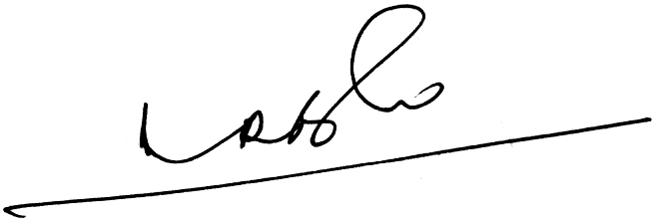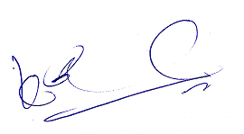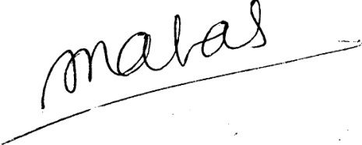
(A Ramesh Babu) (K V Acharya) (S C Jain)
Conveners-CBPRO Gen Secy-AIRBF

