12.03.2019
Shri Arun Jaitley ji
Hon’ble Finance Minister
Government of India
North Block
New Delhi.

Honourable Sir,

Updation of Pension and Improvement in Family Pension

We wish to invite a kind reference to our letter dated 03.01.2019 wherein we have listed out the pending issues and grievances of Bank Pensioners and Retirees. We had also impressed upon the need for resolution of such of those issues which have been causing serious concern and hardship to the Senior and Super Senior Citizens from the Banking fraternity who had served the country and helped take Banking services to nook and corner of the country and hitherto neglected sectors of the society. We have always conducted ourselves as a vehicle of carrying out various schemes of the Government for the upliftment of poor and direct benefit transfer to more than 33 crores beneficiaries of PMJDY accounts. Having served the country during prime of their life, the Bank Pensioners and Retirees fondly look forward to your good self for much awaited relief through redressal of their grievances in the evening of their life before breathing their last.

We are extremely glad to know that the Government of India, Ministry of Finance, Dept of Financial Services vide its notification dt 05.3.2019 has approved the long pending demand of the RBI Pensioners to update their Pension as per the formula given in the said notification. It is a welcome step. We congratulate and thank you for this gesture.

The decision of the Government to grant extension of the benefit of Updation of Pension to the Employees & Officers of Reserve Bank of India has given a ray of hope to the other Pensioners & Retirees of the Banking Industry that similar demand from them shall also be considered immediately so as to benefit more than 7.00 lacs families who have been patiently waiting for Updation of Basic Pension for more than two decades.

- Updation of Pension:

Further we would like to draw your kind attention on the following points in support of Bank Retirees demand for Updation.

- Our request for Updation is not a request for any fresh benefit. Pension Regulation 35(1) provided for Updation of Basic Pension and Additional Pension in respect of those Employees/Officers who retired between 01.01.1986 and 31.10.1987 and at the time of introduction of Pension Scheme in Banks during 1995-96 it was so given to them as they alone were eligible for Updation at that stage.

- Periodic Wage Revision entails periodic Pension Updation. Pay Revision and Pension Revision are inseparable. Hence Pension updation has to be implemented in respect of SBI Pensioners, All Public and Private Sector Bank Pensioners who were employees of the member Banks of IBA. More over Pension is a deferred wage and it is paid out of Pension Fund

- Pension Regulation 35(1) was later amended vide Gazette Notification No:9 dated 01.03.2003 providing for Updation of Basic Pension and Additional Pension wherever applicable thus making it an open-ended scheme to provide the benefit of Pension Updation to all Retirees who become eligible on periodical revision of Pay through Industry level Wage Settlements.

- IBA/Government has been denying the benefit of Pension Updation despite clear provision in Pension Regulation 35(1) sighting cost consideration and implications.

- Pension is a Deferred Wage and a property under Articles 19(1) (f) and 31(1) of Constitution of India and hence a statutory obligation of the Banks which are States within the meaning of Article 12 of Constitution of India.

- Pension including updated Pension and Family Pension become payable out of Pension Fund. The present Pension Fund of the Public Sector Banks including State Bank of India is quite robust and healthy at more than Rs. 300,000 crores with potential to afford paymen of 3to4 times of present disbursements on account of Pension and Family Pension.

- In Banks Pension is paid out of Pension Fund which is created by the surrender of the mandated management contribution of Provident fund by the Bank Employees and Officers during their service. Pension is not paid out of profits but out of the Pension Fund so created. Hence payments to be so made as per Pension Regulations will not affect the Balance Sheet of the Banks. Provision, if any for Pension Fund is a charge on Profit & Loss A/c and hence is not payable out of net profit of the Banks. Net profit has to be arrived at only after making all provisions including for payment of Salary and Pension which are statutory in nature. Statutory payments cannot be denied for cost considerations.

.2. Uniform 30% Family Pension at par with Government and Reserve Bank:

- The present methodology of computing Family Pension in Banks provides for a range of percentage from 15 % to 30 % where in a lower percentage is assigned to higher Basic Pay with specified ceiling as a cap on Basic family pension.

- The above methodology effectively results in the Family Pension working out merely to 7 to 10% of last drawn pay restricting Basic Family Pension to a meagre sum of Rs. 4,000/- to Rs. 14000/- after attainment of notional age of 65 years by the deceased employee or 7 years from the date of death whichever is earlier.

c. Government and RBI Pensioners are paid Family Pension uniformly at 30% of last drawn pay without any ceiling.

d. Un-affordability of proposed improvement in Family Pension is being arbitrarily quoted to deny the benefit despite there being adequate provision made during the service tenure of the employee by the Bank for payment of full Pension to the employee. Thus Family Pension being lesser than the Pension of the Employee, it would involve a negative cost to the Pension Fund. Hence the contention of IBA/Government about cost consideration defies logical, economic sense, rationality and above all humane consideration.

e. Family Pensioners are largely the widows and hence the issue of rendering justice to them at par with Government and RBI pensioners assumes greater and emotive significance. Improvement in Family Pension at par with Government and RBI family pension is therefore a genuine need and merits a sympathetic consideration.

Since it is a very emotive and justified issue, we earnestly request you to intervene and help much deserving Family Pensioners largely the women folk.

We as the coordination of Bank Retirees Organisations representing 100% of Bank Pensioners and Retirees, have conducted dharnas and demonstrations at about 30 important centres throughout the nation and more than 1,00,000 Bank Retirees and Pensioners had participated. The success of our demonstrations and dharnas is a reflection of the seriousness of the Pending issues and anxiety in the minds of Senior Citizens about protracted delay in redressal of their grievances by a government which is known for its objectivity, transparency, speed, and fairness in disposal of the pending matters. In this background we once again request your good selves to consider all our pending issues more particularly the foregoing two important and urgent issues:

It is thus clear that the cost of Updation will be absorbed by the yield on the Pension Fund without denting the Balance Sheets of the Banks in any manner whatsoever.

Honourable Sir, We have fond hope of getting justice at your hands and hence we on behalf of more than 7,00,000 Bank Pensioners and Retirees make an earnest and fervent appeal to your good self to consider our above requests favourably and help resolve the same by advising Indian Banks’ Association and Dept of Financial Services, at the earliest.

With Respectful Regards,

Yours faithfully,

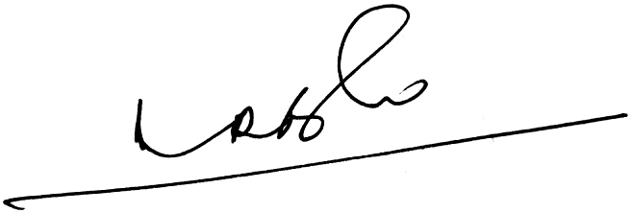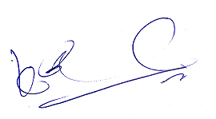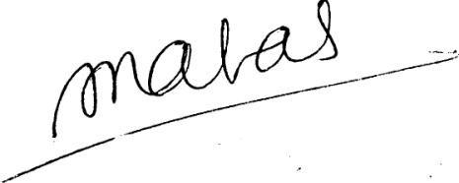
(A.Ramesh Babu) (K.V. Acharya) (S.C. Jain)
Joint Conveners, CBPRO General Secretary, AIBRF

