                                                                                                 Dated: 13.06.2019

To

Shri V G Kannan,

Chief Executive,

Indian Banks Association,

Mumbai.

Respected Sir,

**Re: UNIFORM 30% FAMILY PENSION IN BANKS**

The issue of improvement in family pension at a uniform rate of 30% of last drawn Basic Pay was a subject matter of discussion at the time of last Wage Revision which was concluded during April/May 2015 (effective 01.11.2012).  Since the issue remained unresolved it was so listed in the record note signed by IBA and UFBU.  There was an assurance given by IBA that the issue of improvement in family pension being a fair and reasonable demand will be resolved in a couple of months’ time.  However, despite a lapse of more than four years, the issue remains unresolved.  We have been given to understand time and again that IBA is engaged on the issue and it will be resolved shortly.

The merits of the case for improvements in family pension at a uniform rate of 30% are mentioned hereunder:

a.       Family Pension in Banks is payable @ 30%, 20% and 15% of last drawn pay where lower percentage being assigned to higher pay with a specified ceiling on the amount of Basic Family Pension.

b.      The above methodology effectively resulted in the Family Pension working out to nearly 7 to 10% of last drawn pay restricting Basic Family Pension to a meager sum of Rs. 4,000/- to Rs. 14000/- after attainment of notional age of 65 years by the deceased employee or 7 years from the date of death, whichever is earlier.

c.       Government and RBI Pensioners are paid Family Pension uniformly at 30% of last drawn pay without any ceiling.  The pension scheme in Public Sector Banks was introduced on the lines of Central Civil Services Pension Rules and Pension Regulations 56 expressly provided for a reference to these rules in case of any doubt.  Hence there is a strong case for uniform family pension @ 30% of last drawn basic pay as available in Government and RBI

d.      Despite all the hopes given by IBA at the time of signing the record note on pending issues of retirees in 2015, the issue remains unresolved on the pretext of the requirements of AS15R, actuaries’ estimates of incremental provision etc. Pension Regulations do not contain any reference to AS15R and the actuaries’ estimates are needed for making adequate provision which cannot be construed as a prohibitive clause to render justice.

e.      Un-affordability of proposed improvement in Family Pension is being arbitrarily quoted to deny the benefit despite there being adequate provision made during the service tenure of the employee by the Bank for payment of full Pension to the employee. Thus Family Pension being lesser than the Pension of the Employee, it would involve a negative cost to the Pension Fund.  Hence the contention of IBA about cost consideration defies logical, economic sense, rationality and above all humane consideration.

f.        Family Pension being a highly emotive issue needs to be resolved urgently as assured at the time of last Wage Settlement vide second issue listed in Record Note dated 25th May, 2015.

We request your good self to resolve the issue immediately as it is also an emotive issue consisting of large number of spouses of Retirees who happened to be women in the Super Senior category.

Thanking you,

Yours Sincerely,

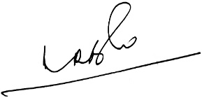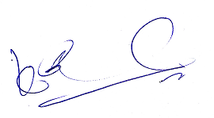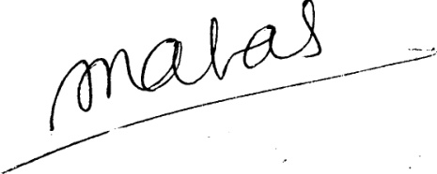(A.RameshBabu) (K.V. Acharya) (S.C. Jain)

Joint Conveners, CBPRO General Secretary, AIBRF